**Acoustic Underwater Communication in Pure sea, clean ocean beds, Costal oceans and Turbid ocean**

Yash Belliappa S T 1, and Ananda M2

1PES University,Bengaluru,India

[1yeshbelliappa@gmail.com](mailto:1yeshbelliappa@gmail.com)

Ananda M

PES University Bengaluru,India

4[anandam@pes.edu](mailto:anandam@pes.edu)

**Abstract.** This project introduces a novel approach to underwater optical communication technology by using Matlab tool to checkat various changes in the concentration, attenuation, SNR and Receiver power. The Matlab simulink will give us a brief idea of how the underwater optical fiber communication works at different depths. This is robust, user friendly, the efficient and powerful system to reach beyond the natural depth of the ocean so that we can do various activities like expedition. Unlike traditional methods to calculate the attentution and the SNR with fixed configurations, our innovation uses dynamic cases that accommodate a diverse range of results. The code connects to a user-friendly web interface, allowing users to find the necessary details effortlessly. Upon receiving an information the system orchestrates the Mariners and ocean expeditors accurately and promptly. This project addresses the limitations of advanced Case studies, offering a versatile and responsive solution to meet the modern underwater optical fiber communication more independent on adding external sources to reach higher depths.

**Keywords:** robust, efficient, Matlab, Data precision, fetchable Results Plots .

**1 Introduction**

Introducing a groundbreaking leap in underwater acoustic communication technology, the case study on Acoustic Underwater Communication in ocean beds revolutionizes the traditional paradigm by seamlessly integrating cloud data to help marine drives achieve the change in technology to be made with confidential and precise connectivity with the higher officials .This avant-garde approach transcends the conventional limitations of fixed configurations, ushering in a new era of dynamic adaptability. Upon the initiation of entering the prediction data through the matlab interface, the interface springs into action, leveraging the precision of input data and the flexibility according to change in concentration rate to ensure with unparalleled accuracy and promptness. This intricate dance of technology ensures that the modern underwater expeditionist’s demands for convenience and efficiency.

The Beer-Lambert law is a linear relationship between the absorbance and the concentration, molar absorption coefficient and optical path length of a solution: The molar absorption coefficient is a sample dependent property and is a measure of how strong an absorber the sample is at a particular wavelength of light.

**2 PROTOTYPE REQUIREMENTS**

**2.1 Software Requirements**

Matlab, csv file,add-on packages. The symbols are shown below to know how the software symbol looks like.

  

**Fig 0:** Symbols of the software and tool to know the basic interface before use.

**3 DESIGN**

**3.1 Flowchart**

This flowchart starts with the user runs the program and then he has 2 chooses either plot the plot_2.m file or the other files like” Graphs, pentration_power_try, Random_noised_power gen and many more (you will see in the coming graphs) after running the files it will ask for the user input and for the user who chose the plot_2.m file it uses the dataset called “ocean_depths.csv” and plots Attenuation vs Wavelength, SNR vs Wavelength, and the surface graphs for differentating the different ocean beds. Then if the code runs sucessfully the receiver receives the result else error in the code or in the dataset same for the plot_2.m file but it depends on first generating the table of missing column results then the plot function works we use scatter, bar,surface etc. As for the other files we run it generates the results for manual meaning the user specification and we can do it for the Dataset created by the user to test the cases or else find a new Dataset from online browser and utilize that in “plot_2.m” to genrate the graphs with respect to the data parameter from the intrested column which must be a missing column and also genrate the calculation results and manually calculate to comapre the results and come to a conclusion.

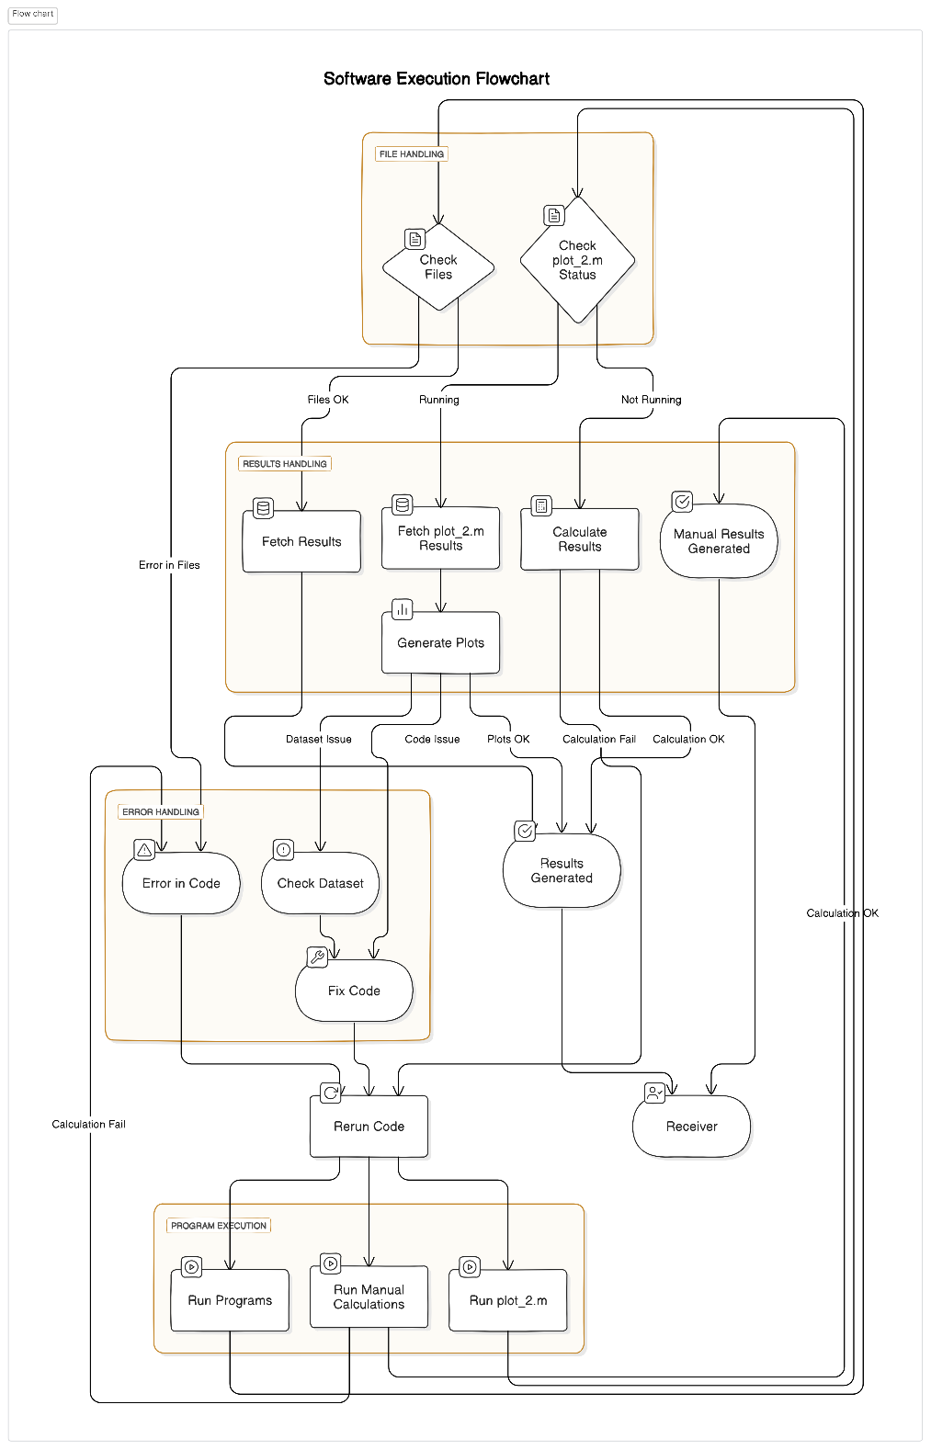  
**Fig 1** Flow chart

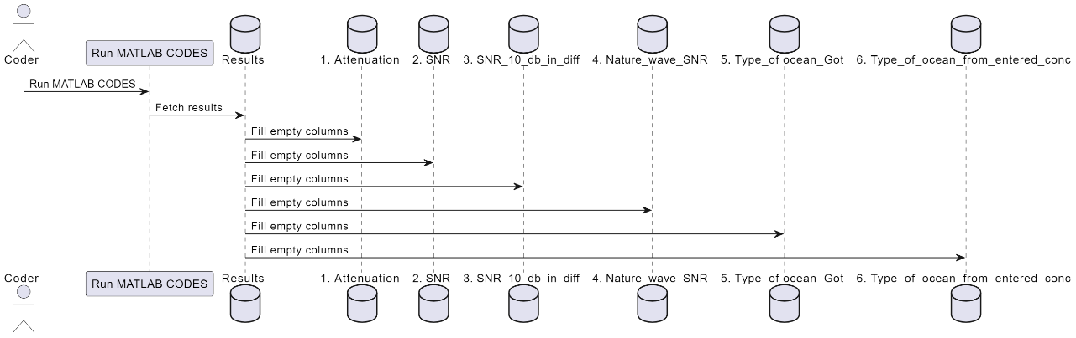

**Fig 2**: Block diagram

**3.2 Depth referance Diagram**

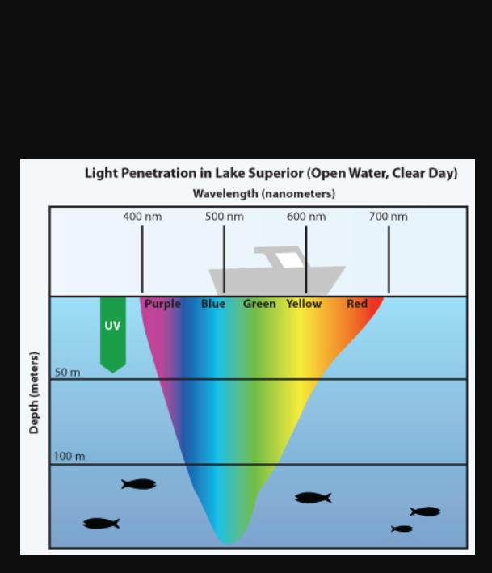

**Fig 2** Depth regions with the wavelength Diagram

**4 IMPLEMENTATION**

**4.1 Code the program**

First understand what is your requirement and also if you are doing it for a organization what is their specifications form that get a clear understanding of what all parameters are independent and dependent. Use datasheet if given because that gives the coder a glimpse on what values to work on.

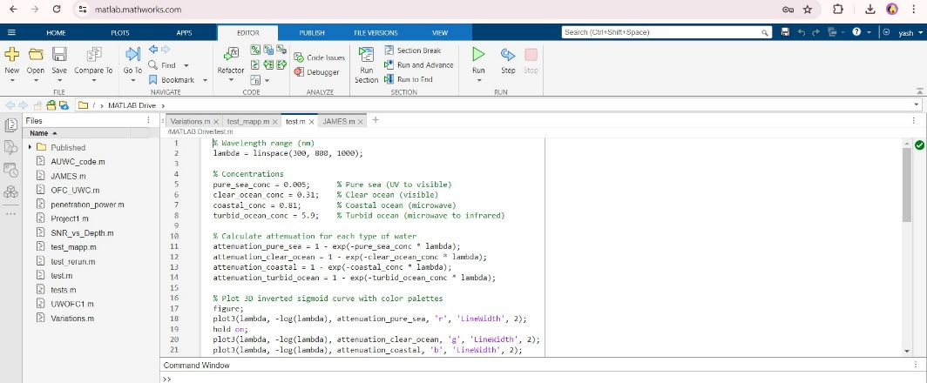

**Fig 3** example Program

**4.2 Run the files without the plots**

First run the files that dont have any plots note down the values. Use the different concentrations for different ocean beds as shown in the below example, use that values to find the SNR vs wavelength using the concentration if you dont use them we cannot predict the nature of the signal at higher wave lengths. We can use the absorption and scattering coefficients to get the received power (pr), nature of the ocean beds, extinction coefficient C(λ), and the file SNR_with_Depths to calculate the SNR for different ocean beds using the depth upto 1000m and the wavelength in nm

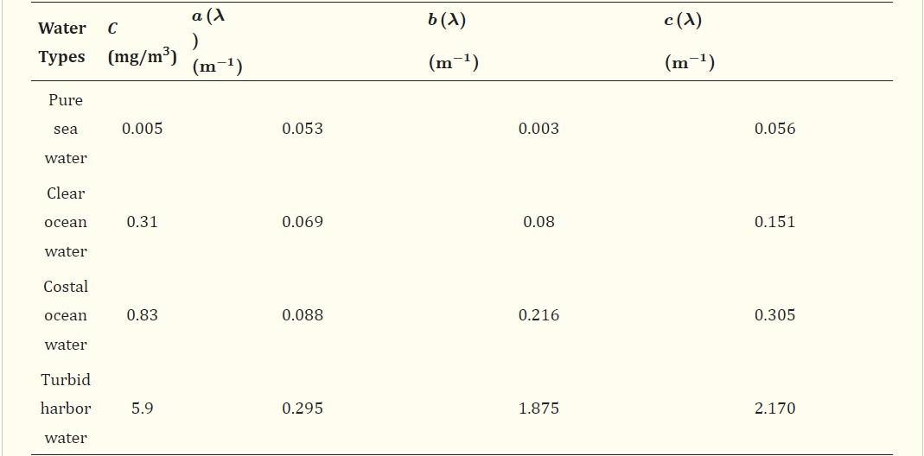

**Fig 4:** The concentration and the absorption coeffiecient and scattering coefficient

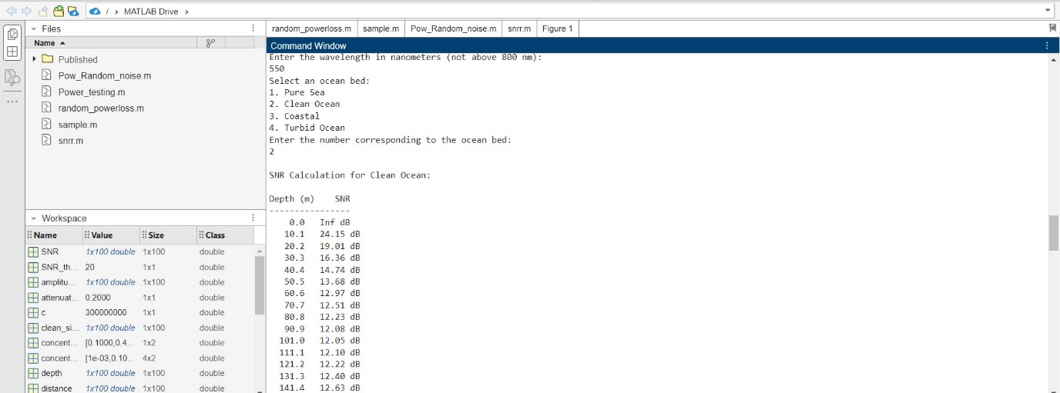

**Fig 4**  Running the program.

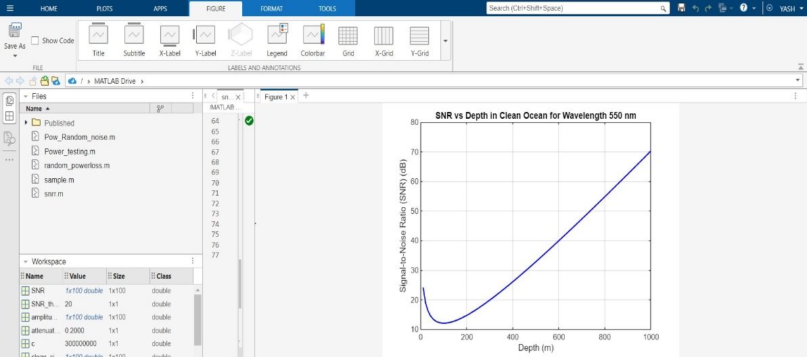

**Fig 5**  Graph genrated for the SNR vs Depth entries.

**4.3 generating for different ocean beds**

Proceed like step 4.2 for the costal ocean, pure sea, turbid oceans and observe the results.

Clean ocean:

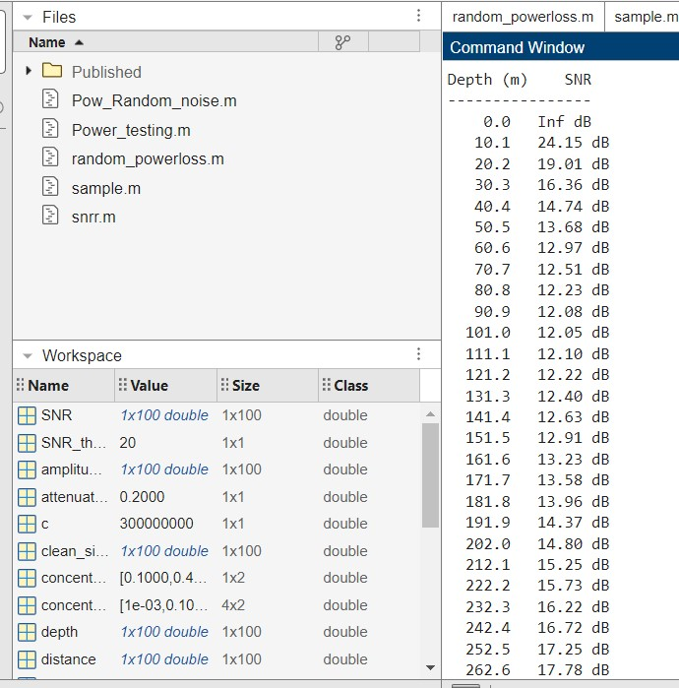

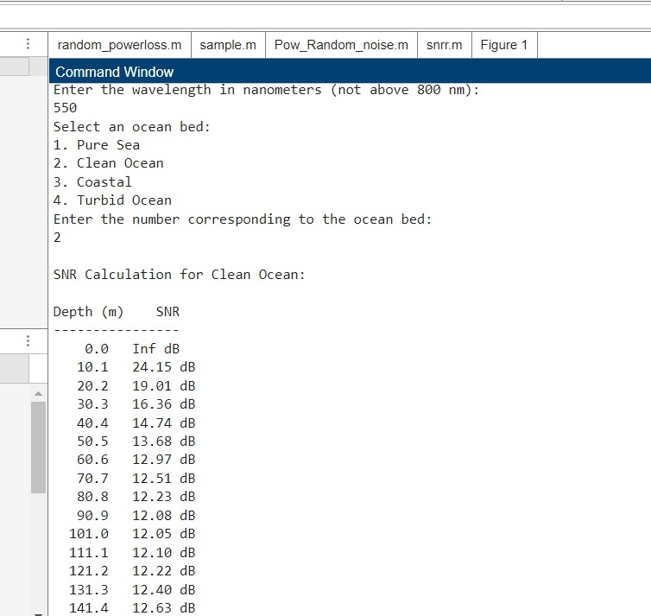

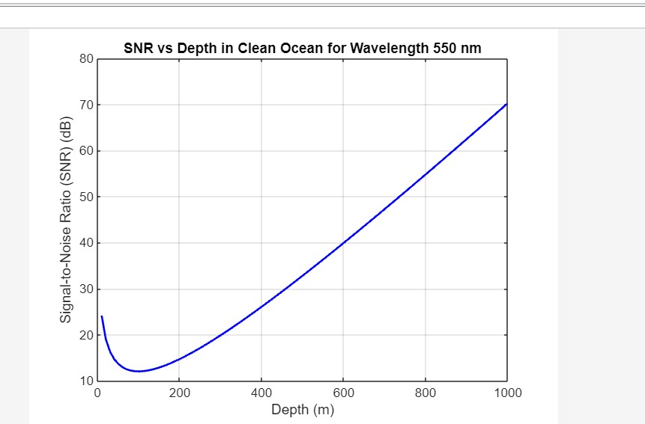

Costal ocean:

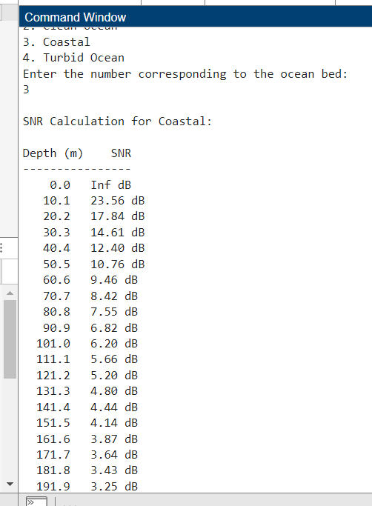 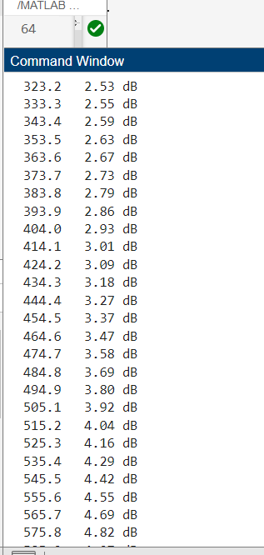 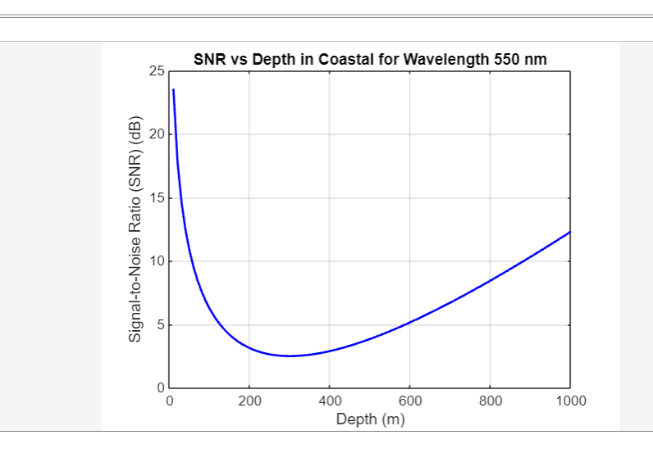

Pure sea:

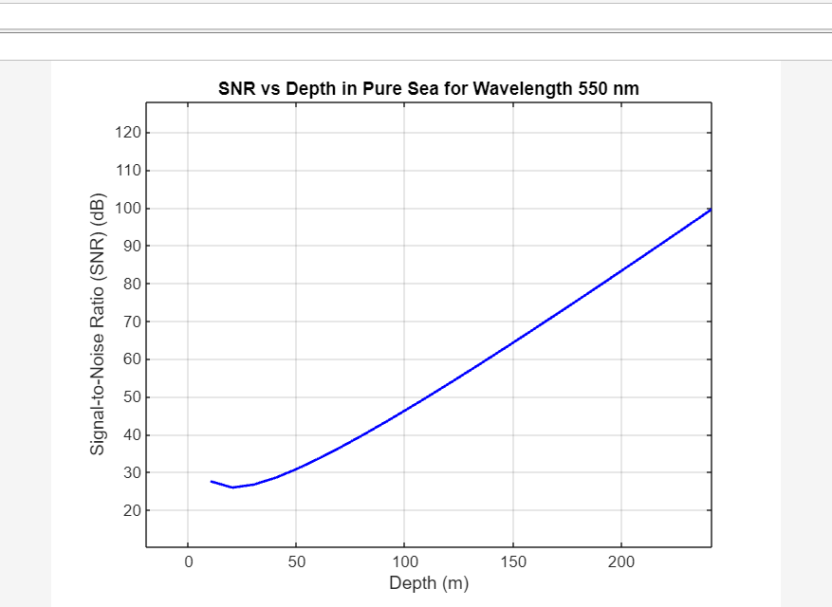

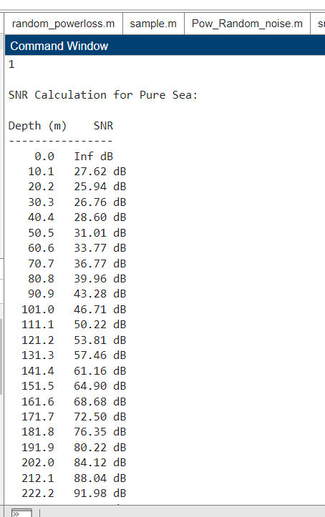

TURBID Ocean:

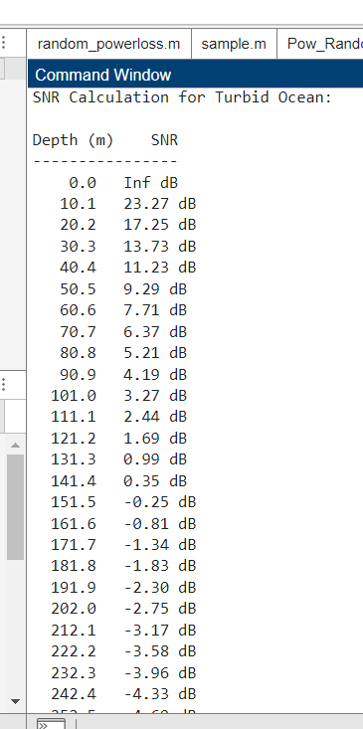

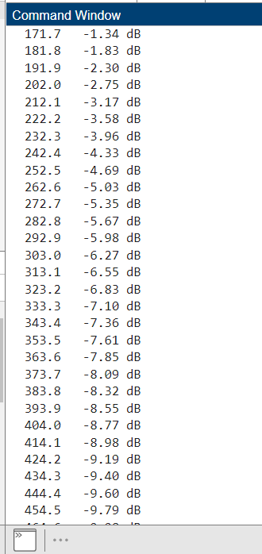

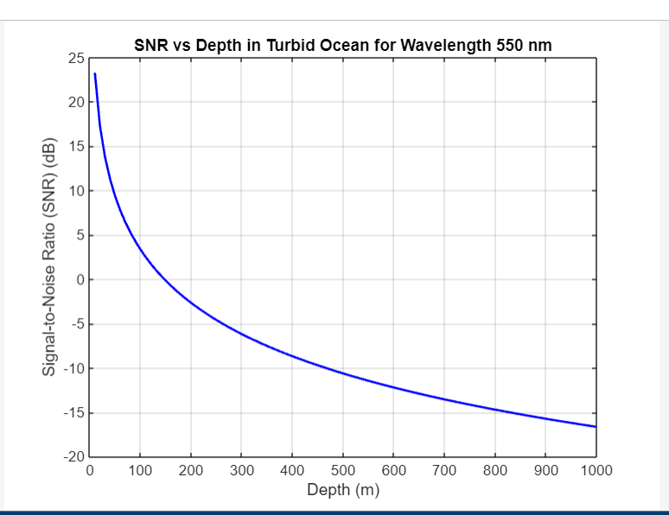

**Fig 6**  the Costal, Pure Sea, Turbid oceans

**4.4 Import Dataset Method**

MATLAB allows the user to import the dataset so if the coder uses the dataset he can clearly get an idea of what is the code functioning for and how it will be shown in form of graphs it will have all the user defined columns called Wavelength, depths and sometimes absorption and scattering coefficient added and the user must fetch the other empty columns like SNR, nature of the ray, nature of the wave etc using the data samples available. If you see the dataset is built already by the user and ready to perform the operation based on the mathematical logic given by the user by the users understanding and generate the results.

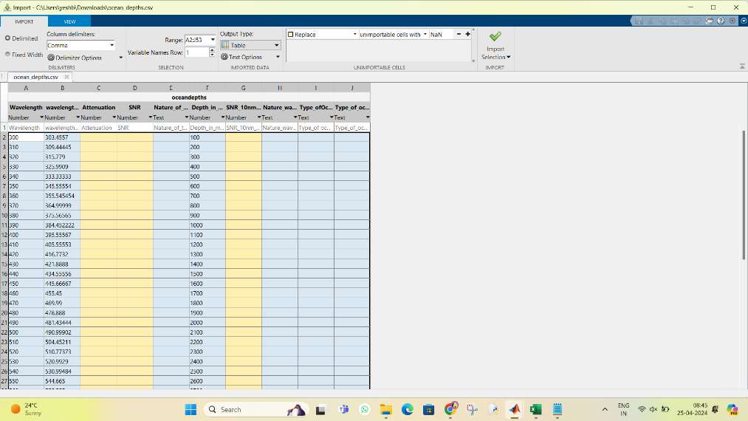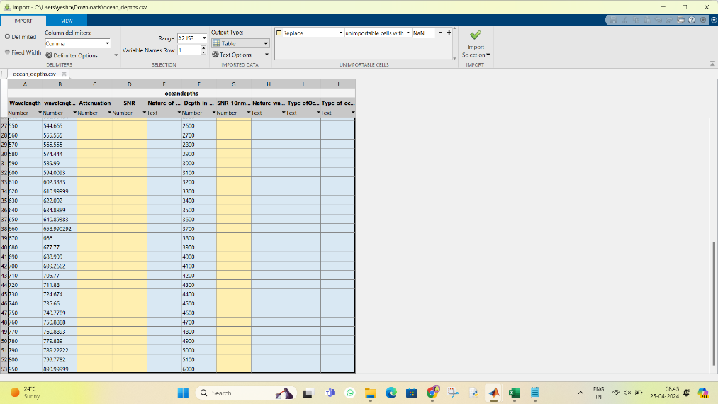

**Fig 8** Dataset

**4.5 Generate the Data**

The results and the plot is fetched.

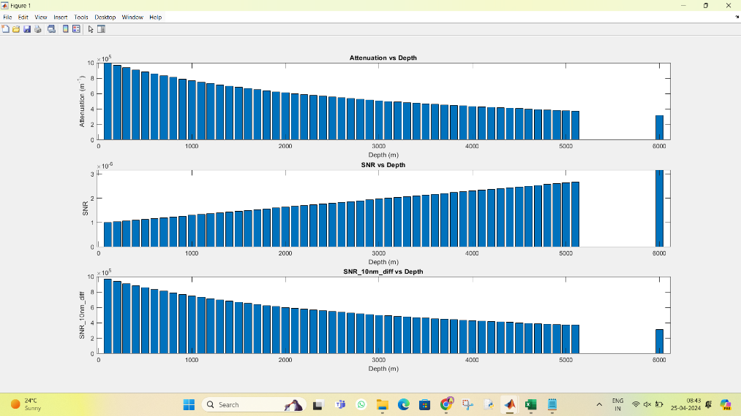  
**Fig 9** Bar plot

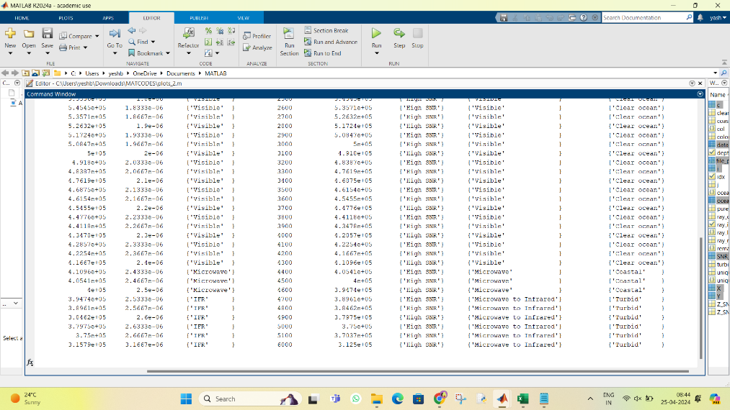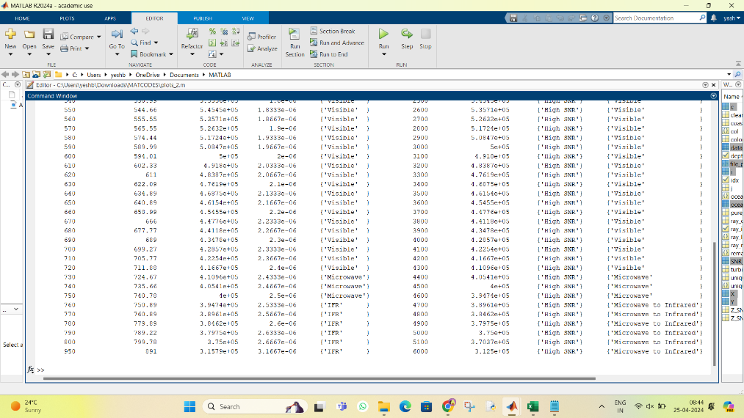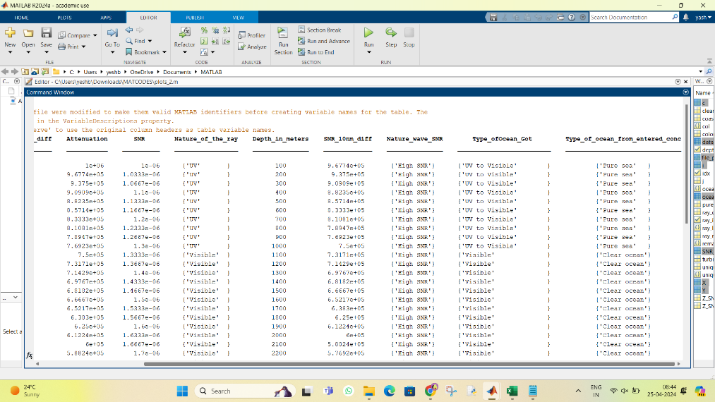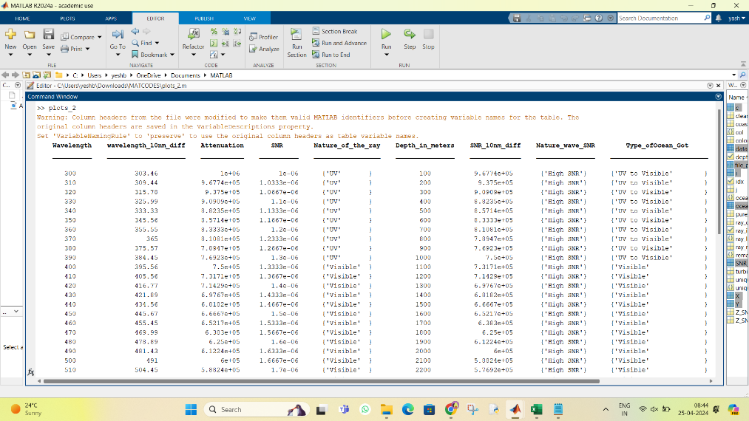  
**Fig 10** Database data fetched after operation

**4.6 parameter: Wave length vs depth and Amplitude vs Depth**

D= lambda, and $Amplitude ∝\frac{1}{λ}$

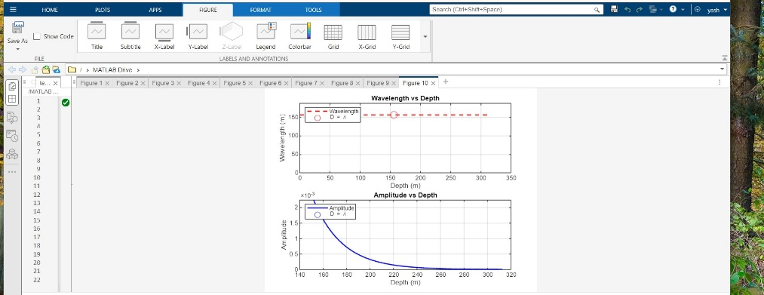

**Fig 11** Plot 1

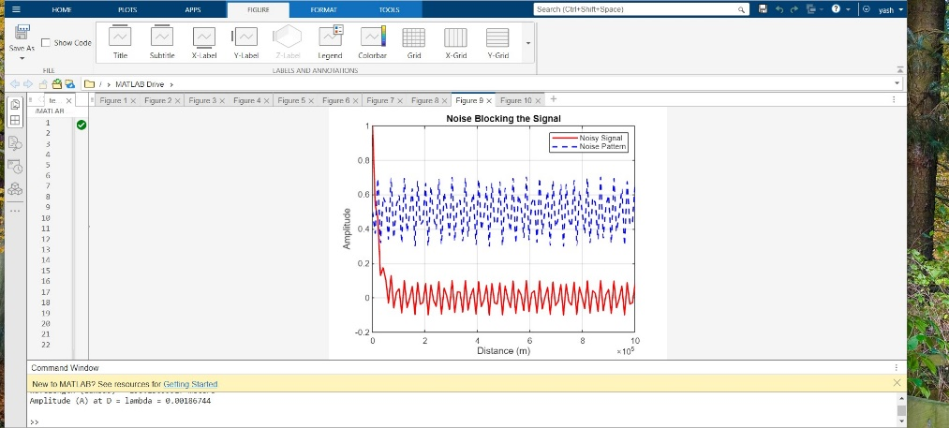

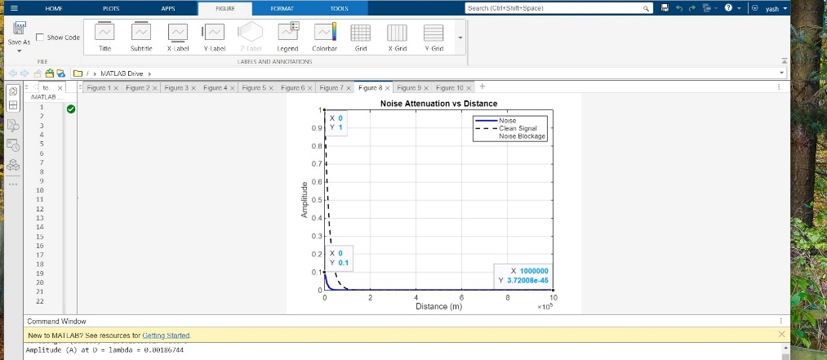

**Fig 12** plot 2

**4.7 Randomization of the samples due to noise**

This is a procedure works lets assume the light travels into the ocean beds when it penetartes the ray sometimes cannot penetrate completely that is the turbid ocean region the Intensity $∝$ Depth. Due to high SNR the intensity rate increases and due to temperature the SNR becomes random but can be high or low depending on the real time jorney.

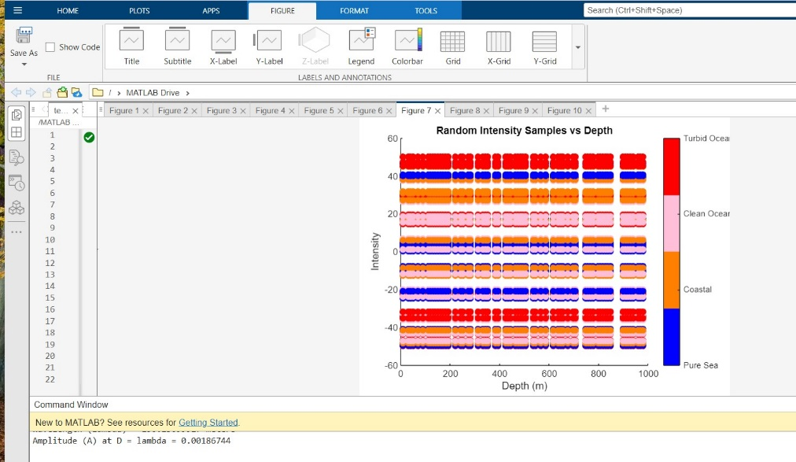

**Fig 14** Randomization of SNR intensity vs Depth

**4.8 Average Intensity vs Depth**

Pure Sea Beds:

Depth: These are areas of the ocean that are far from the coast and characterized by deep water.

Intensity-Depth Relationship: In deep, open ocean areas, the intensity-depth relationship for both water and sound waves tends to decrease with depth. This is because wave energy is dispersed over a larger volume of water as depth increases. Sound waves propagate through deep water with relatively uniform intensity.

Coastal Ocean Beds:

Depth: Coastal ocean beds are found closer to the shorelines and typically have shallower depths.

Intensity-Depth Relationship: Near the coast, the relationship between intensity and depth can be more complex due to the interaction between waves and the ocean floor. In shallow coastal areas, such as continental shelves, wave energy can concentrate near the surface due to the shallower depth, leading to higher intensity. However, as waves approach the shoreline, they can break, causing turbulence and reducing intensity.

Turbid Ocean Beds:

Sedimentation: Turbid ocean beds are characterized by high levels of suspended sediment particles, often due to factors like river runoff or coastal erosion.

Depth: The presence of suspended sediment can reduce water clarity and light penetration, affecting the depth of light penetration into the water column.

Intensity-Depth Relationship: In turbid ocean beds, light intensity decreases rapidly with depth due to the scattering and absorption of light by suspended particles. Sound waves can also be attenuated more rapidly in turbid waters due to scattering and absorption by suspended particles, leading to lower intensity with depth.

Clear Ocean Beds:

Sedimentation: Clear ocean beds have lower levels of suspended sediment and greater water clarity.

Depth: Water clarity in clear ocean beds allows for greater light penetration, resulting in deeper light penetration compared to turbid waters.

Intensity-Depth Relationship: In clear ocean beds, light intensity decreases more gradually with depth compared to turbid waters. Sound waves also experience less attenuation, resulting in higher intensity at greater depths compared to turbid waters.

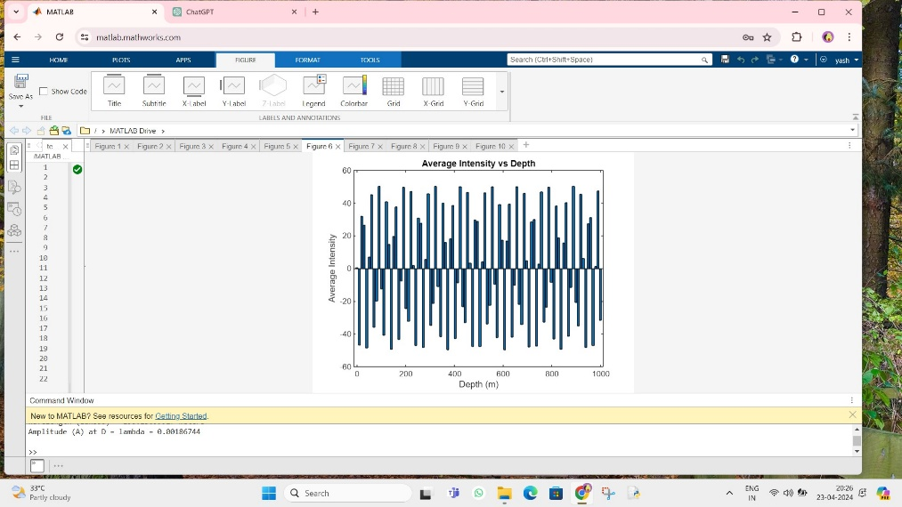

**Fig 14** Randomization of SNR intensity vs Depth

**5.1 Average Intensity VS depth for Turbid oceans, clean ocean, costal ocean and pure sea.**

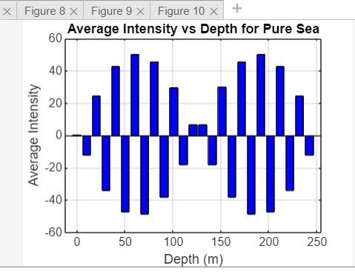

**Fig 15.1** Pure-sea

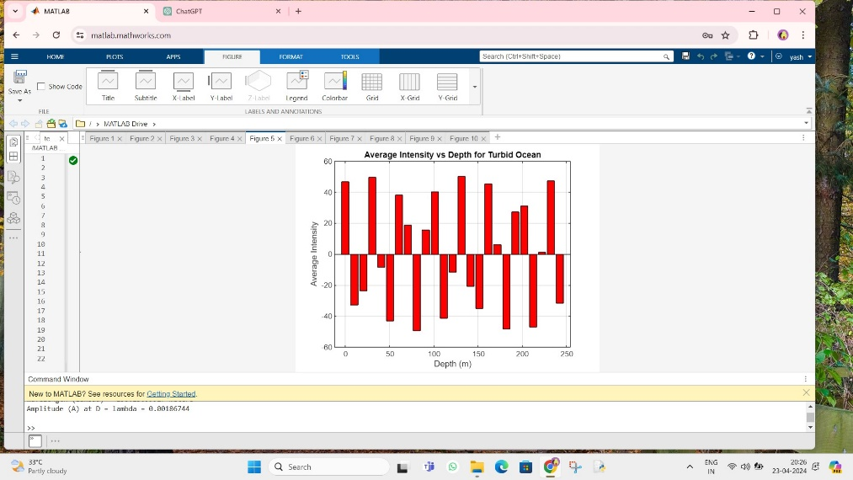

**Fig 15.2** Turbid ocean

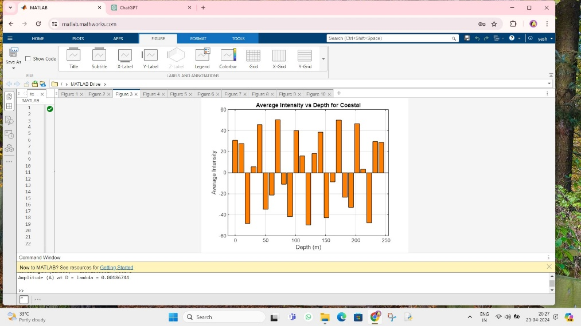

**Fig 15.3** costal ocean

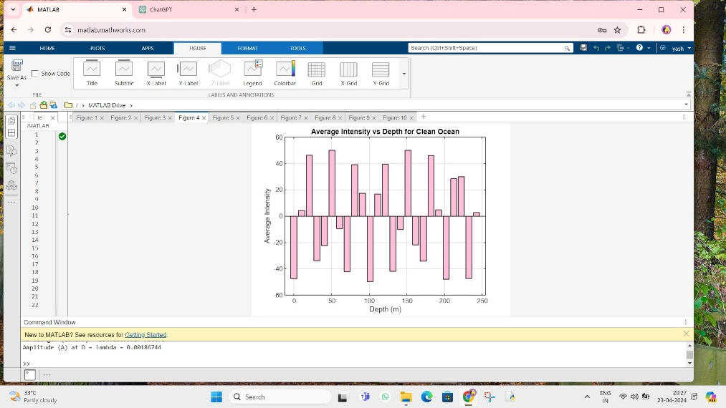

**Fig 15.4** Clean Ocean

**5.2 Results**

CASE: OCEAN BEDS.

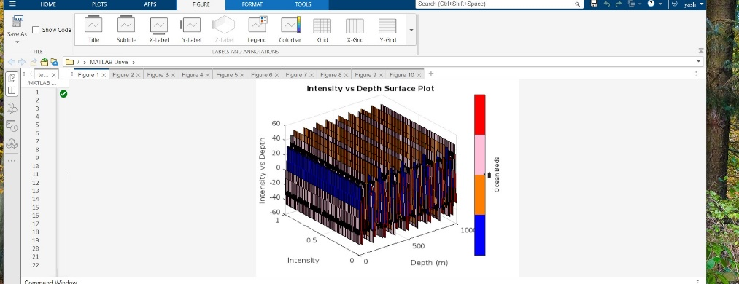

**Side view**

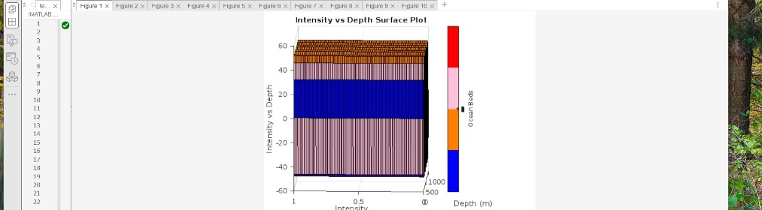

Front view.

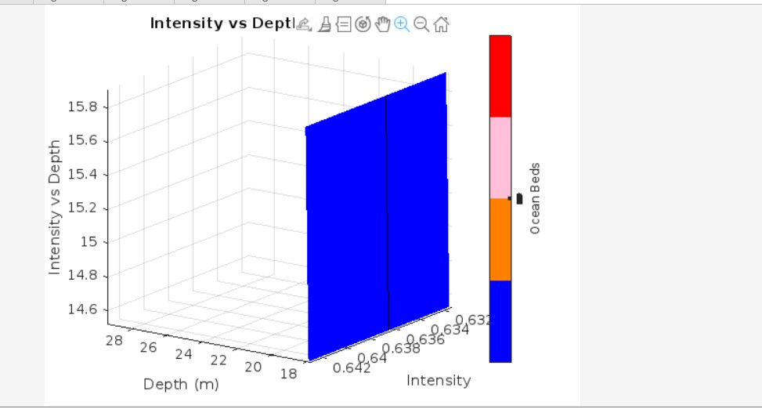

Surf1: pure sea

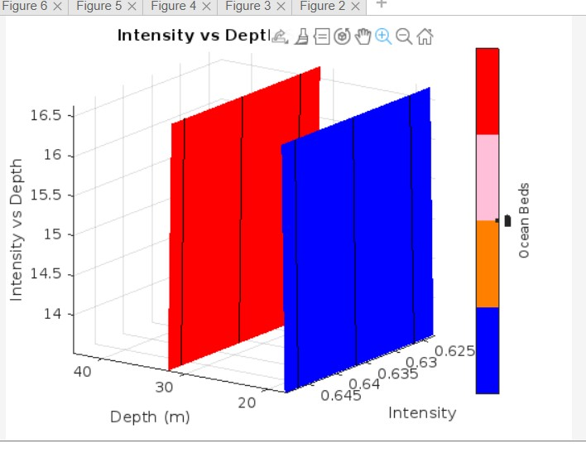

Surf 2: pure sea to Turbid

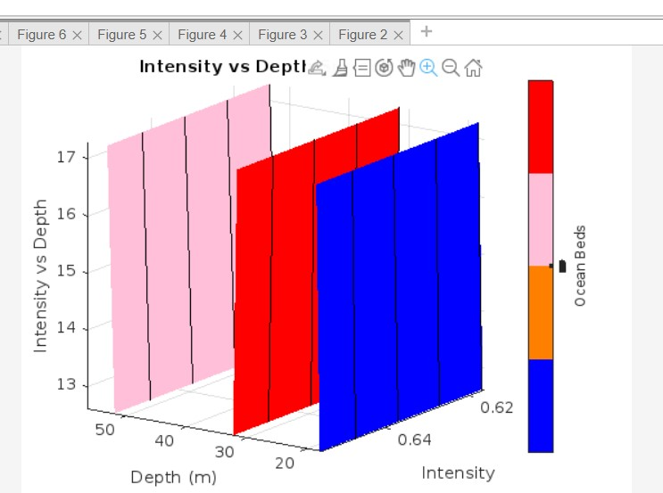

Surf 3: Turbid to clear ocean

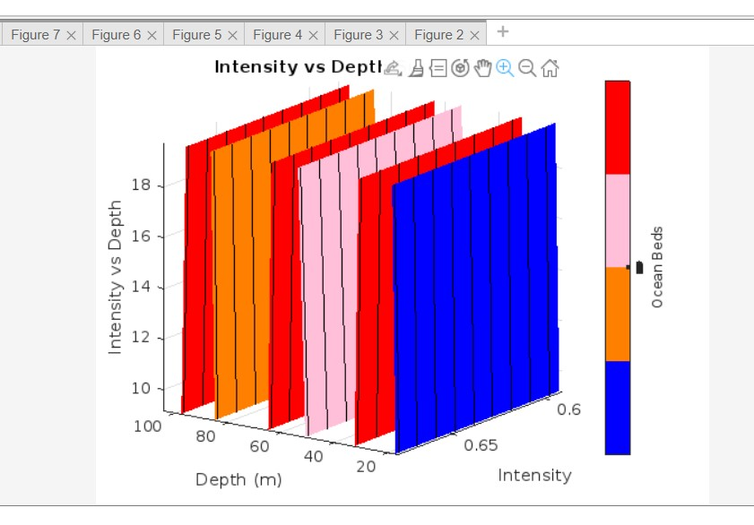

Surf 4: from clear ocean to turbid again and then to the costal then finally turbid region

If you can see these above figures when the light is travelling inside the ocean beds the type of ocean we can see where our light has landed or is still travelling until where the signal is lost. The “blue” is pure sea, “orange” is costal oceans, “pink is clean sea” and the “red” is turbid oceans. The repetition of Turbid indicates that there are possibilities that the light can enter further to larger depths.

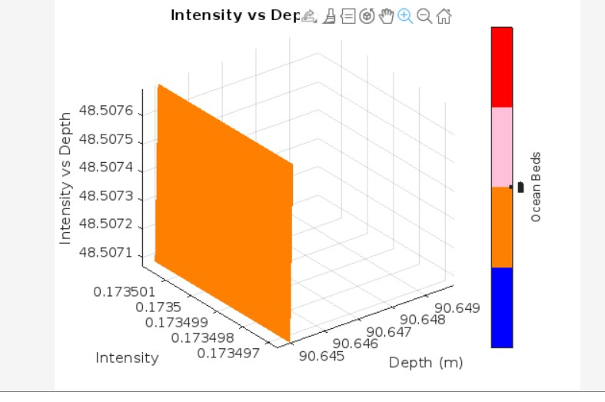

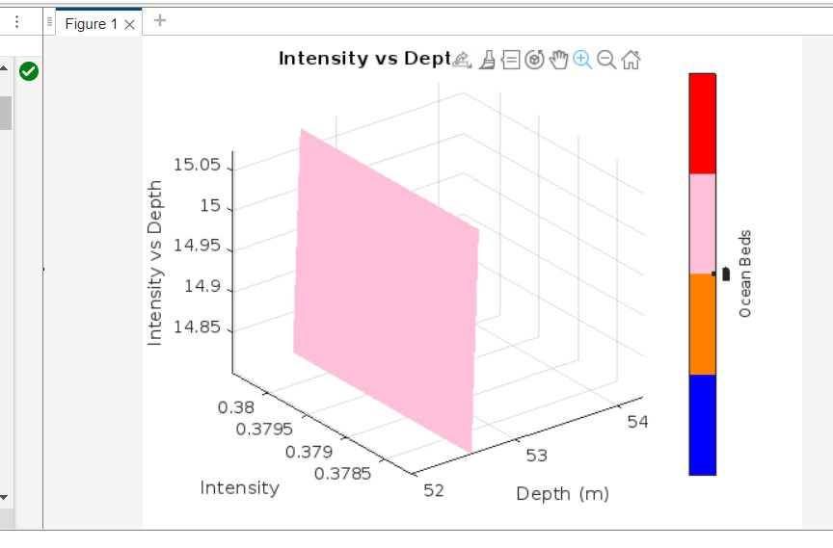

**Fig 17** Light penetration to know the type of ocean beds.

. **6 POWER CALCULATION**

**6.1 Power Scope**

* **Total input power:** The total input power generated by using or giveing the fiber length and the wave attenuation. P_in = sum(avg_intensity) * fiber_length.
* **Total output power:** The total output power is fetched from P_out = P_in * exp(-fiber_attenuation_2 * fiber_length).
* **power loss:** P_loss = P_in - P_out; % Power loss during transmission

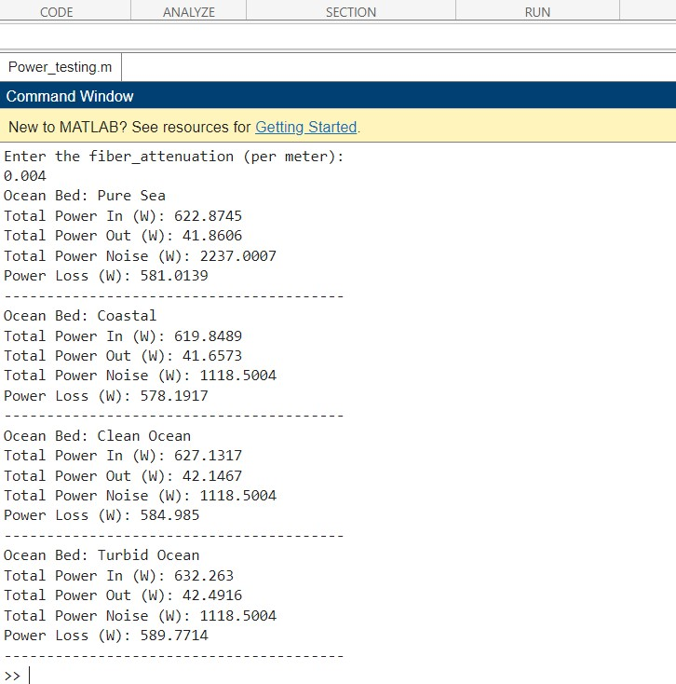

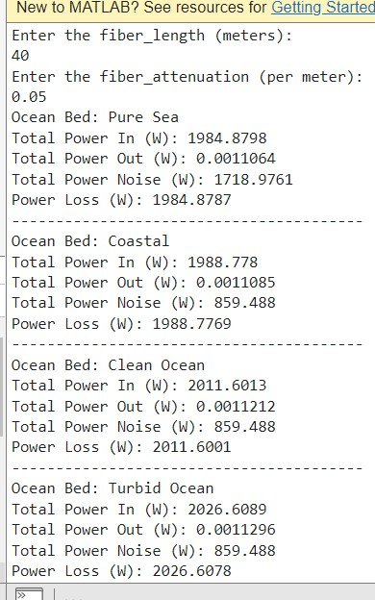

**Fig 18** power calculations

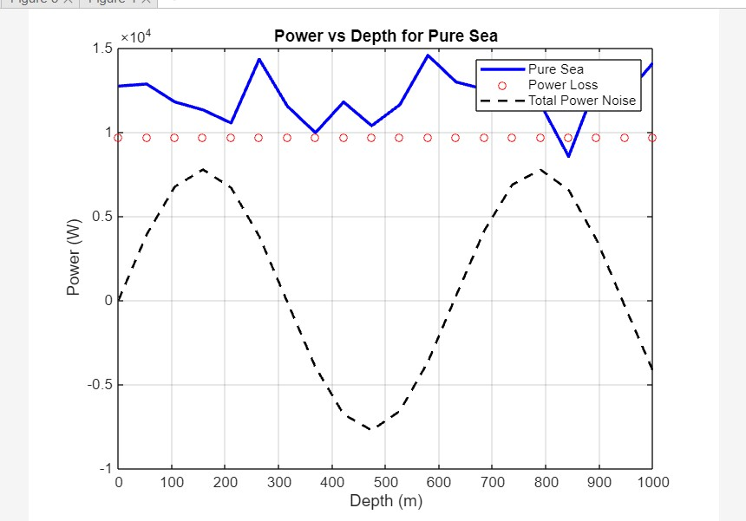

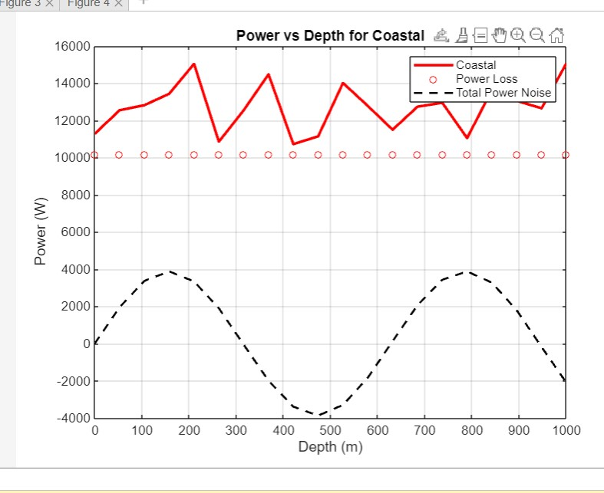

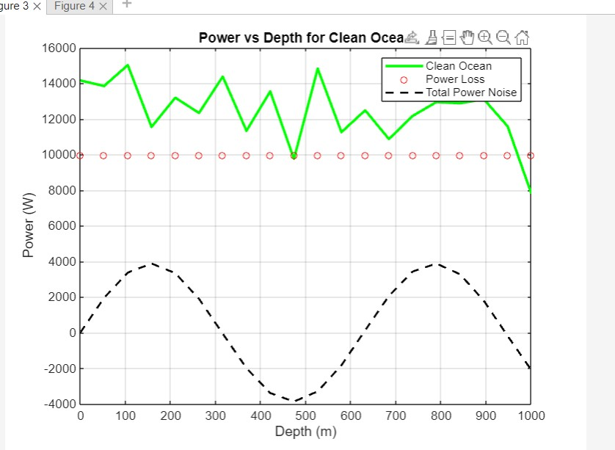

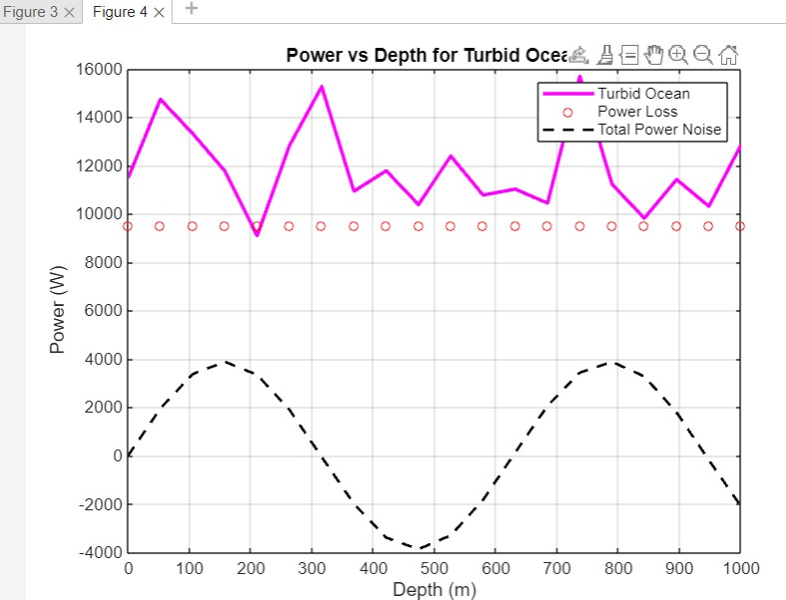

**Fig 19** Power vs Depth of each ocean bed

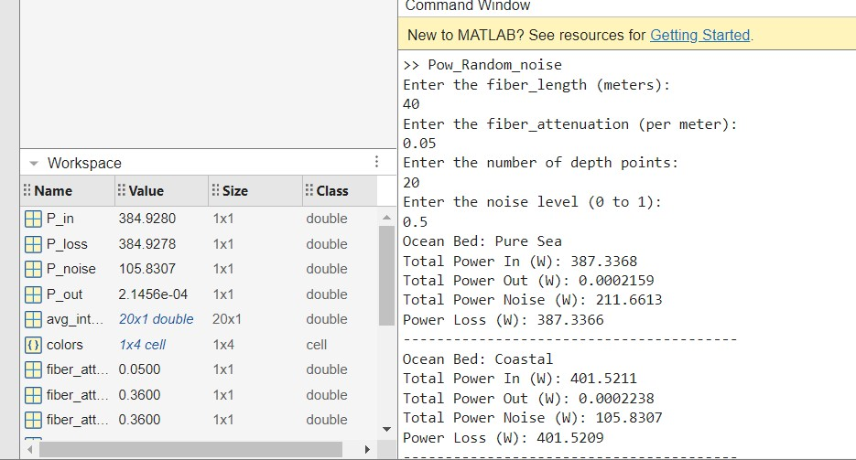



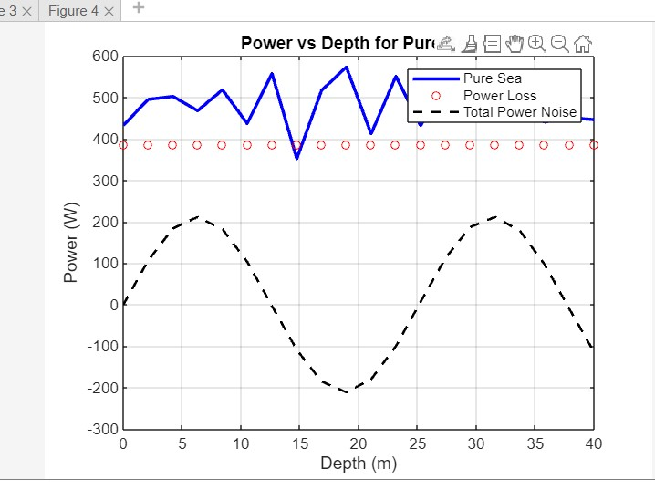

**For pure sea**

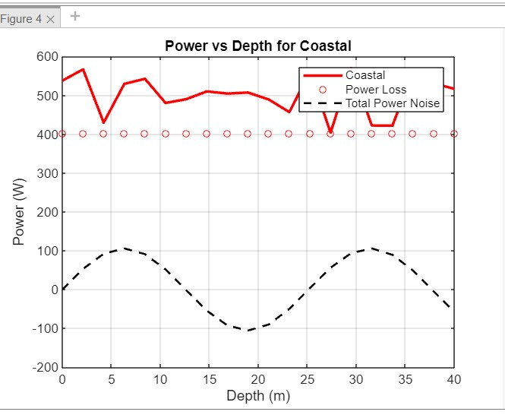

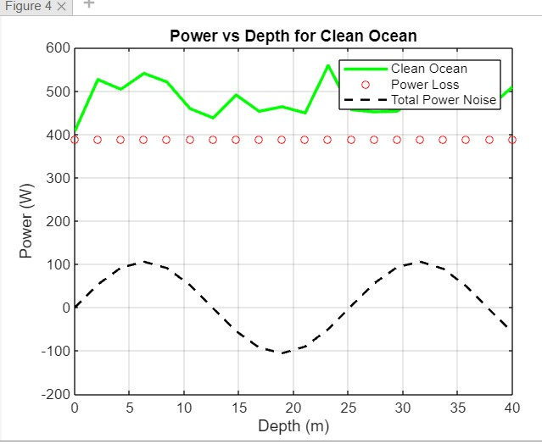

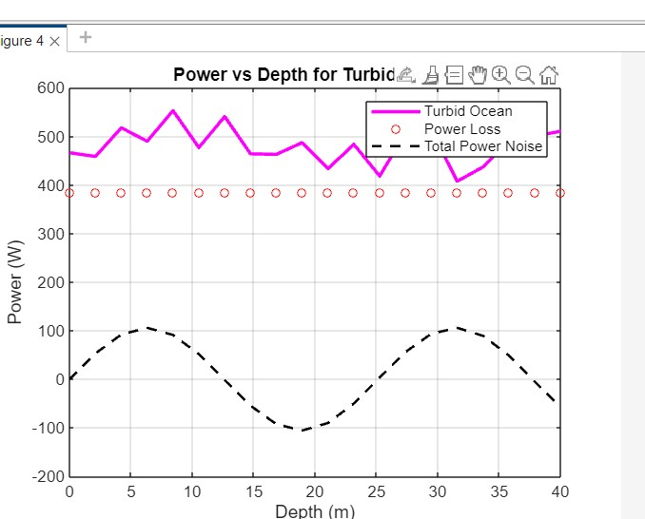

**For Turbid oceans**

**Fig 20** Power vs Depth of each ocean bed with noise

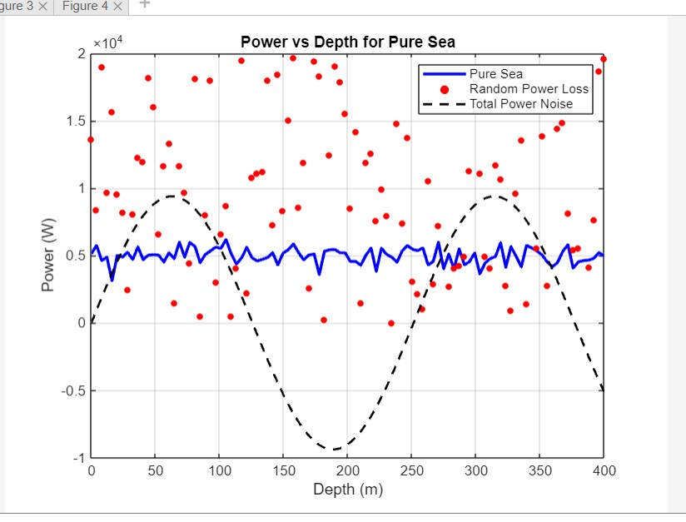

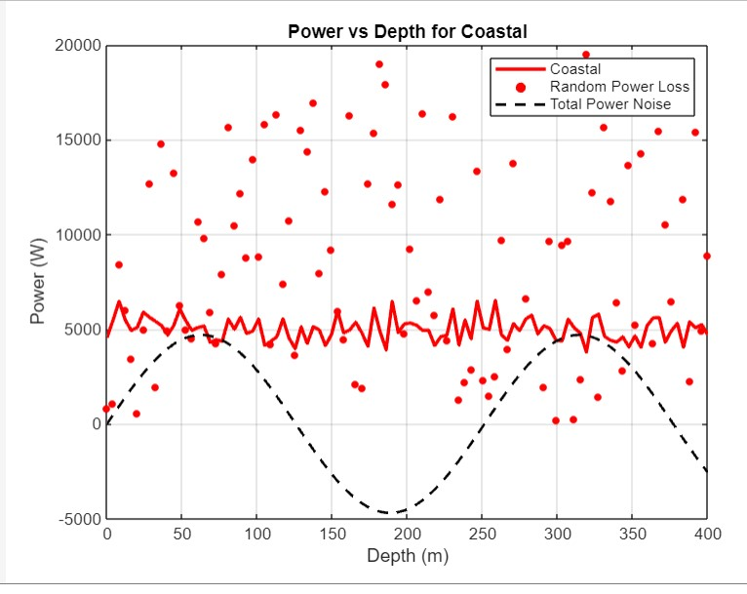

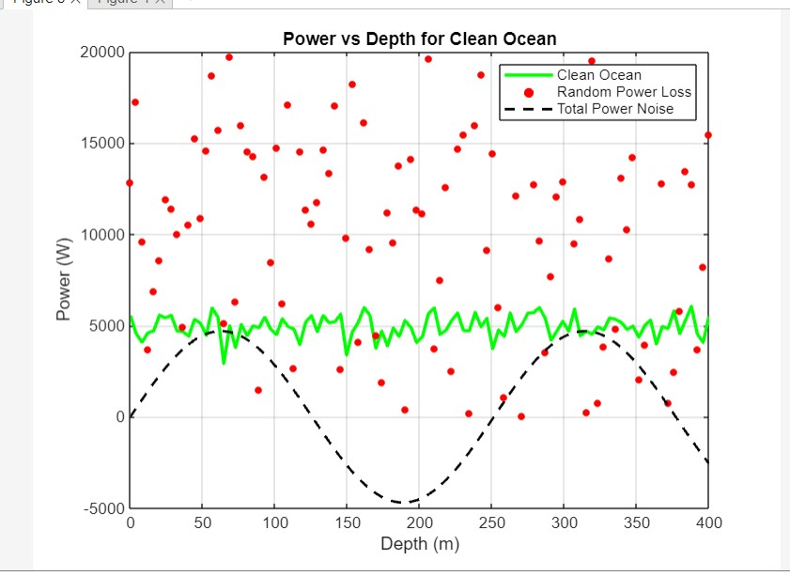

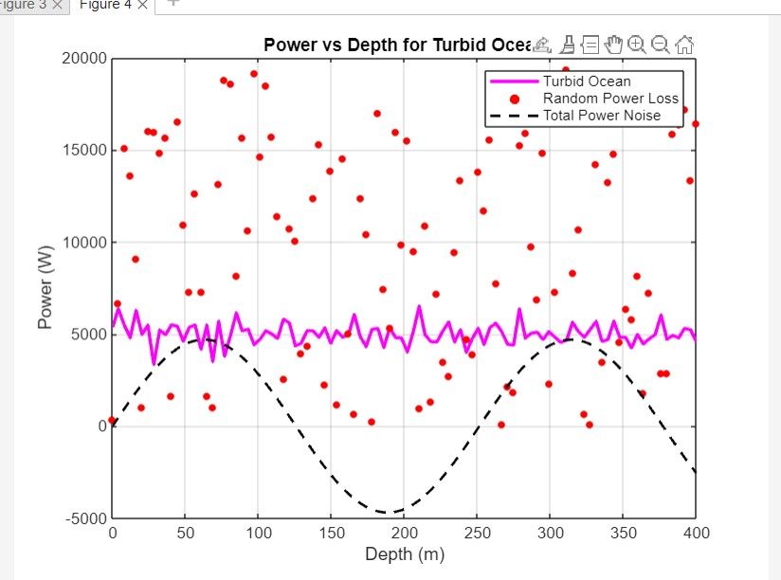

**Fig 21:** Scatter plot version of Figs 20

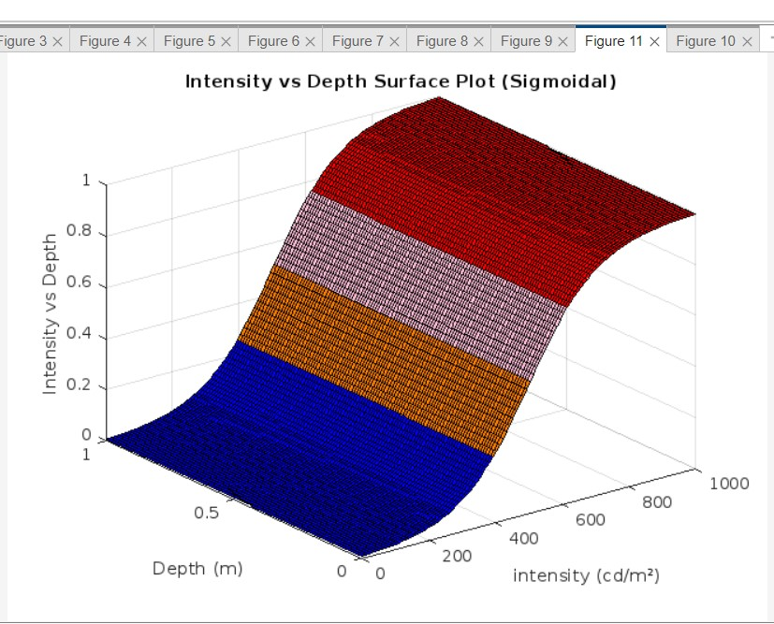

**Fig 22:** Intensity vs Depth Sigmoid curve

**6.2 Power change from the attenuation**

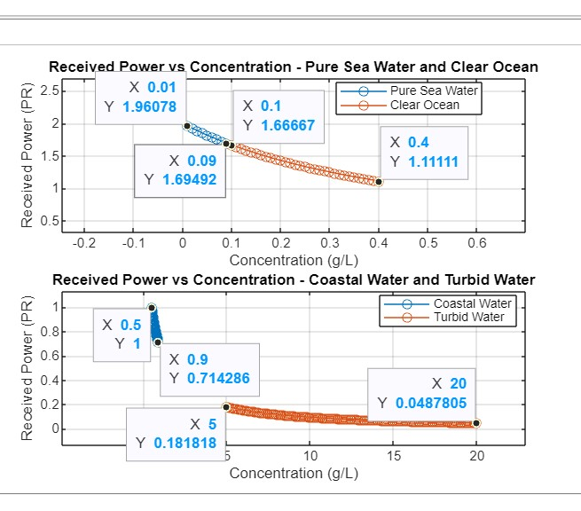

**Fig 23:** Received Power vs concentration of each ocean bed with its power received**.**

Generally received power is directly proportional to concentration.

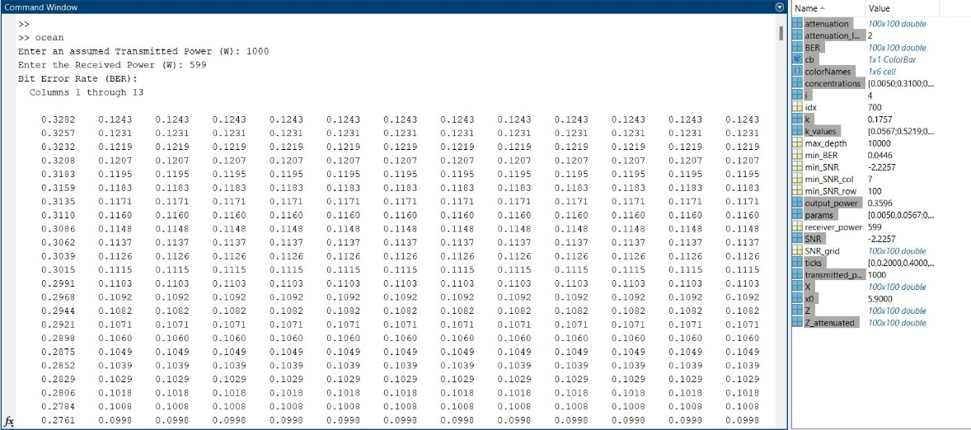

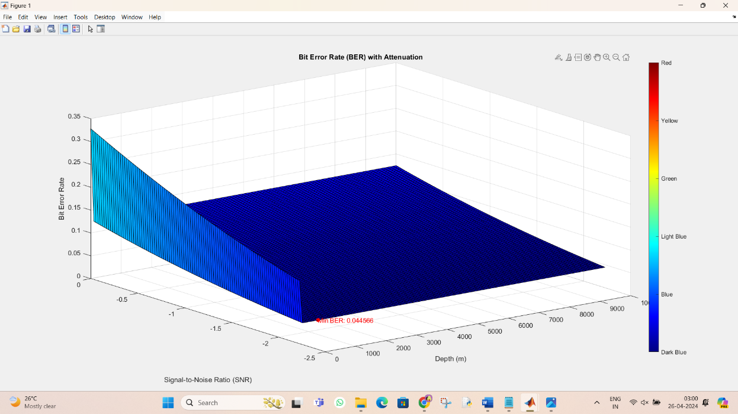

**CASE 1**

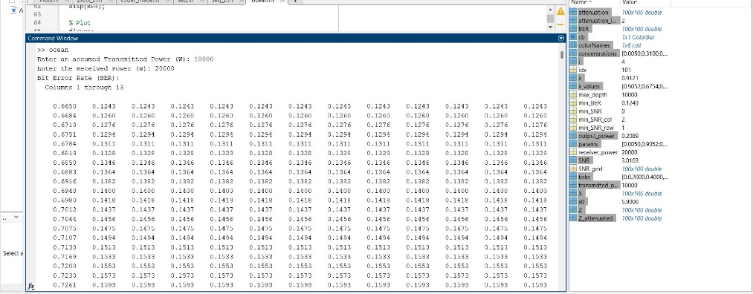

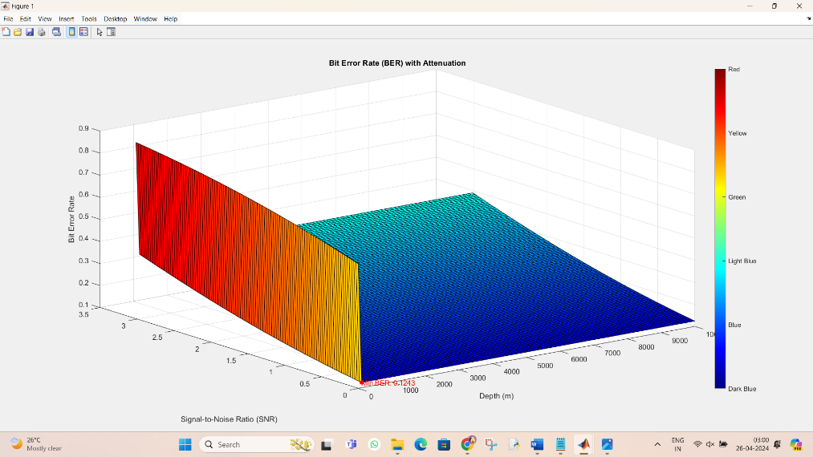

**CASE 2**

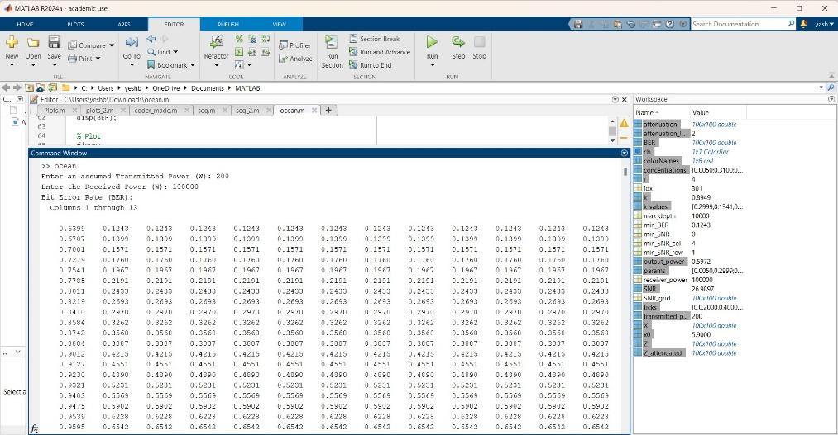

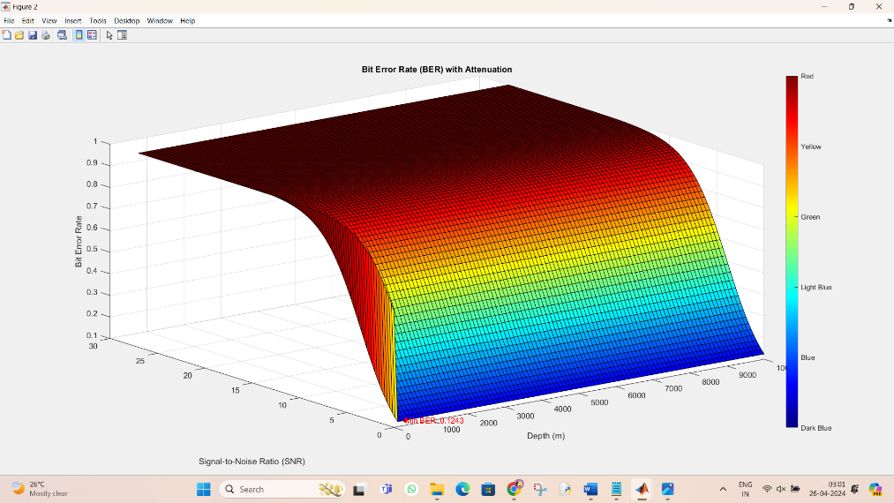

**CASE 3**

**Fig 23.b** BER VS SNR VS Depth(m) in presence of attenuation by user’s input and random change in BER every second.

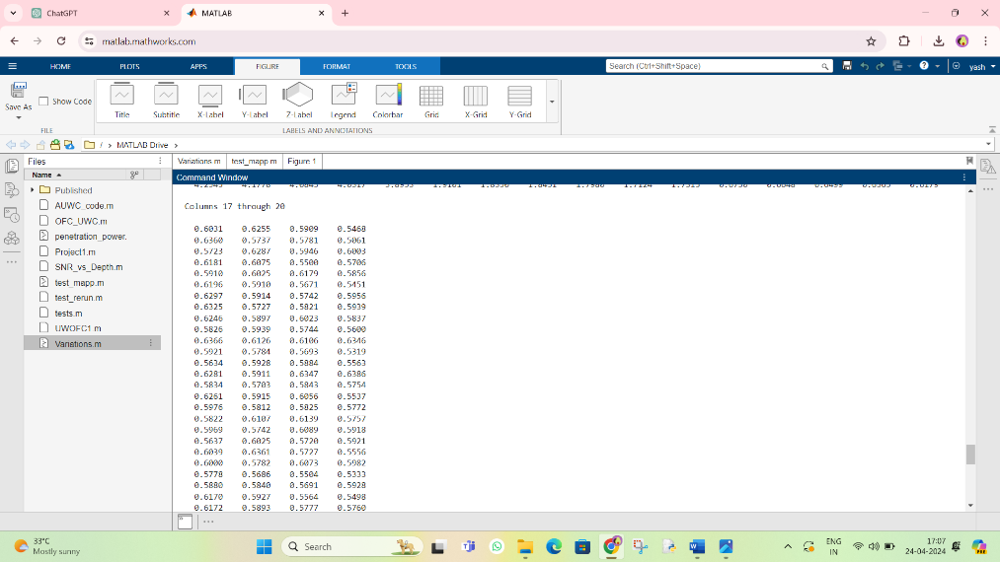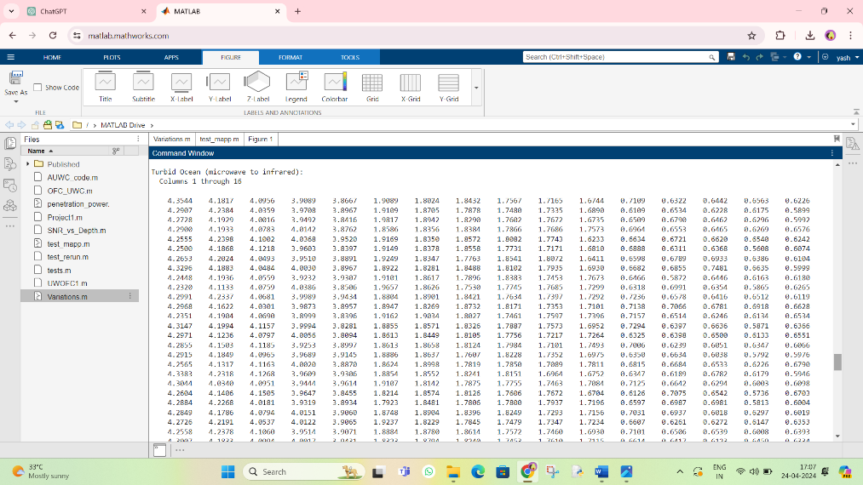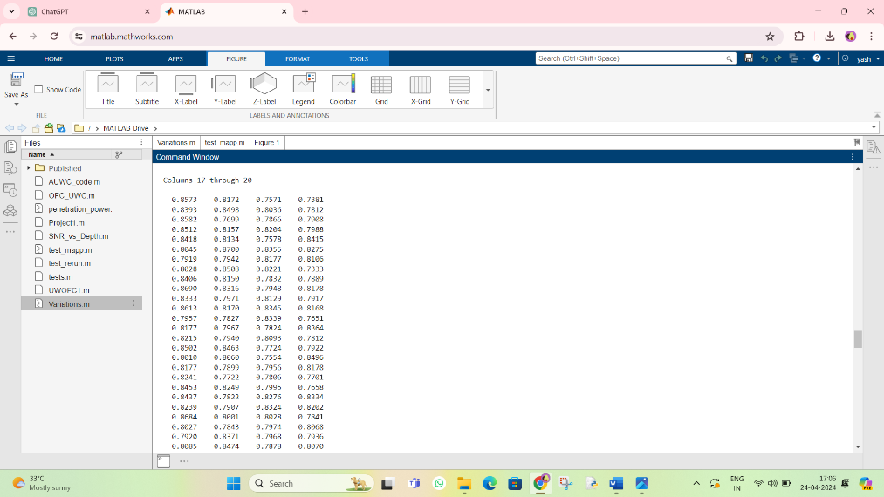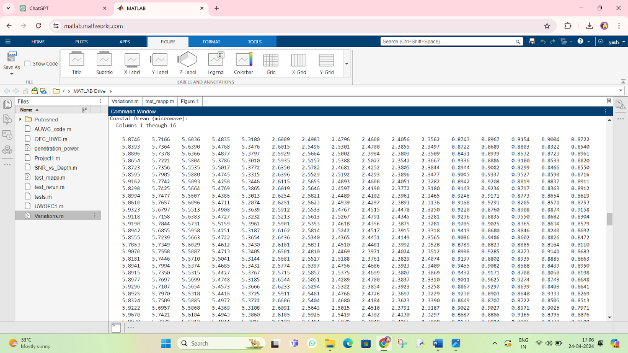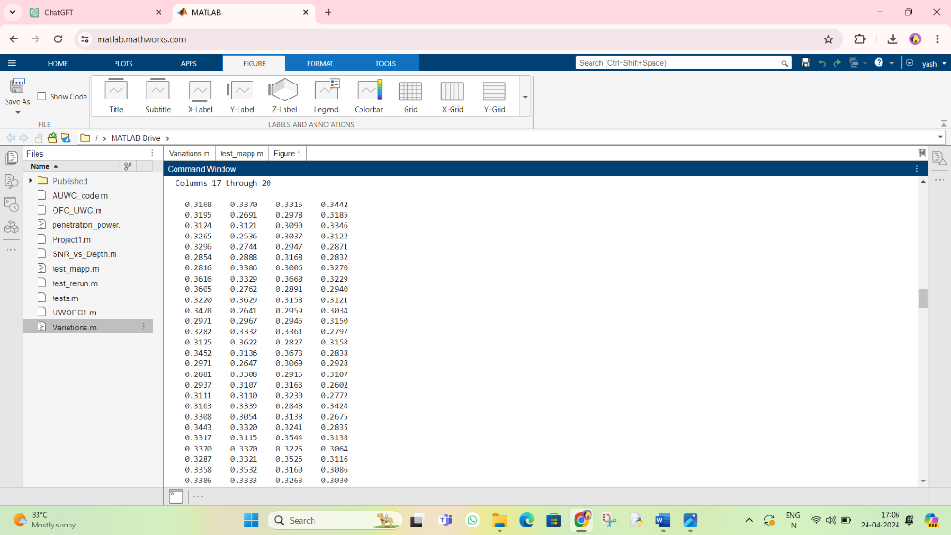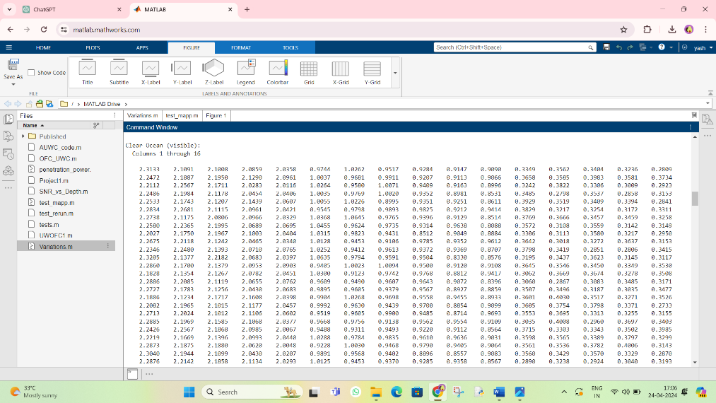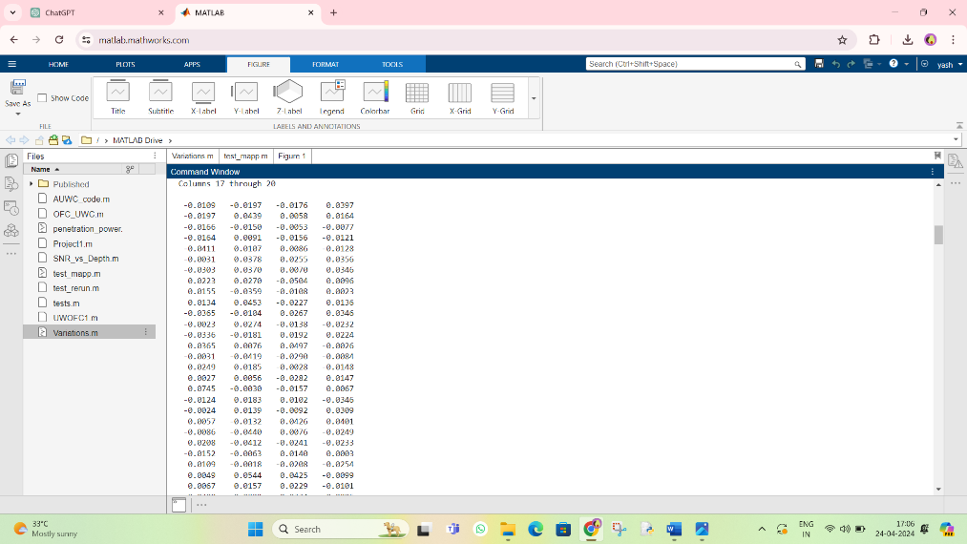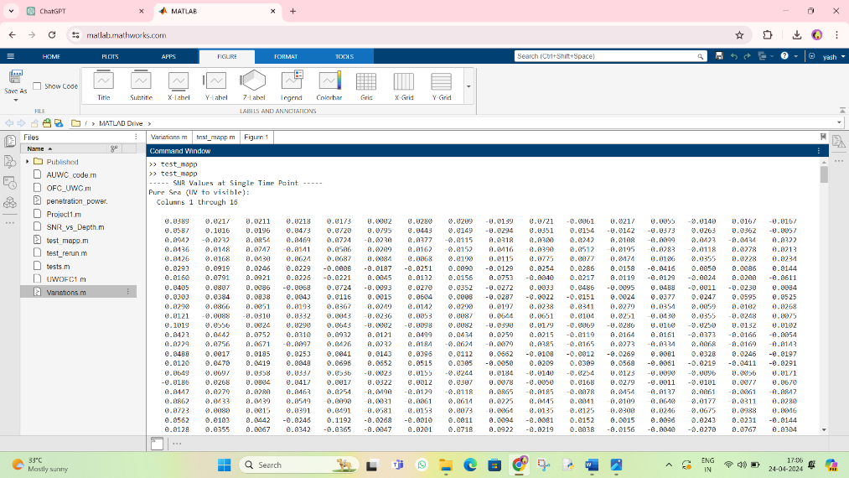

**Fig 24**: SNR for each time like 1,2,3 and so on

We did this because in acoustic region as they depend on the concentration of the salt and another extra chemical the ocean beds are decided by that and when light enters the surface it calculates the SNR till the bottom where the SNR is Infinity so no data is fetched.

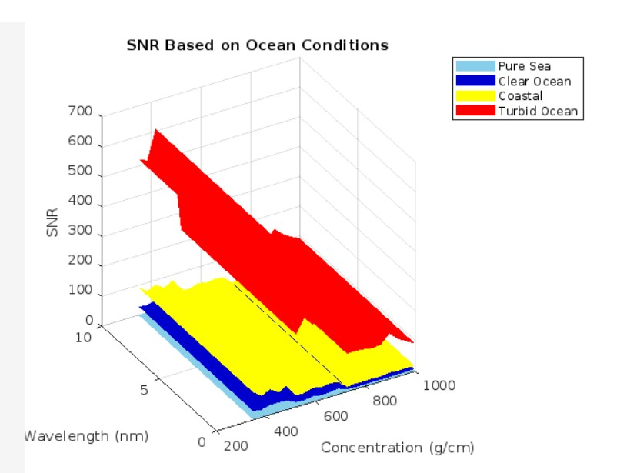

The black lines indicate there is no information(SNR fetched)

This can happen due to disruption of the signal, low attenuation and low intensity.

**Plot:** SNR based on ocean beds

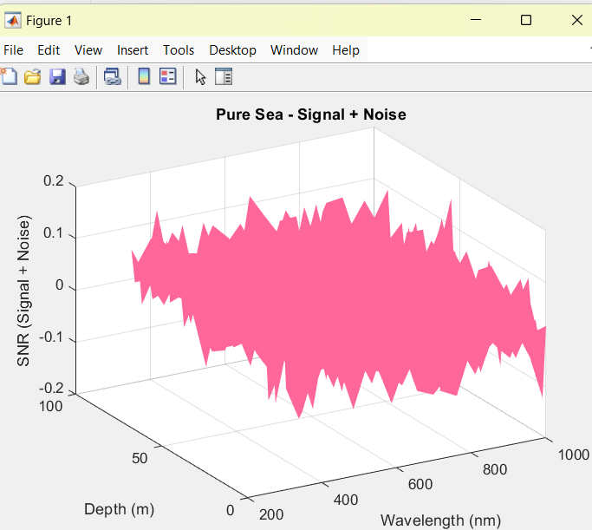

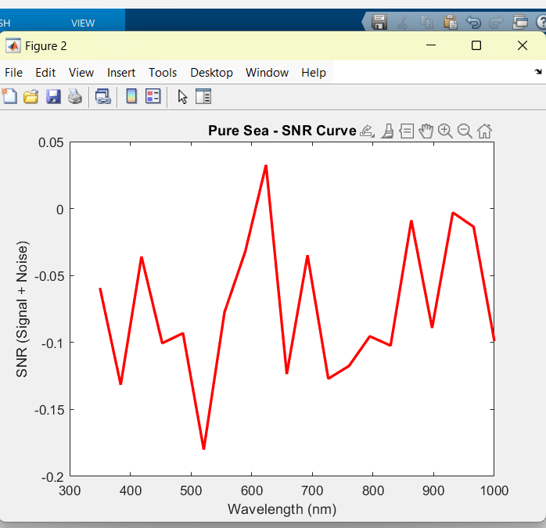

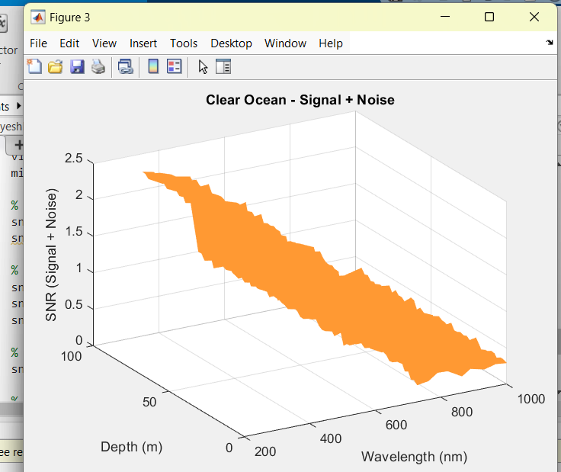

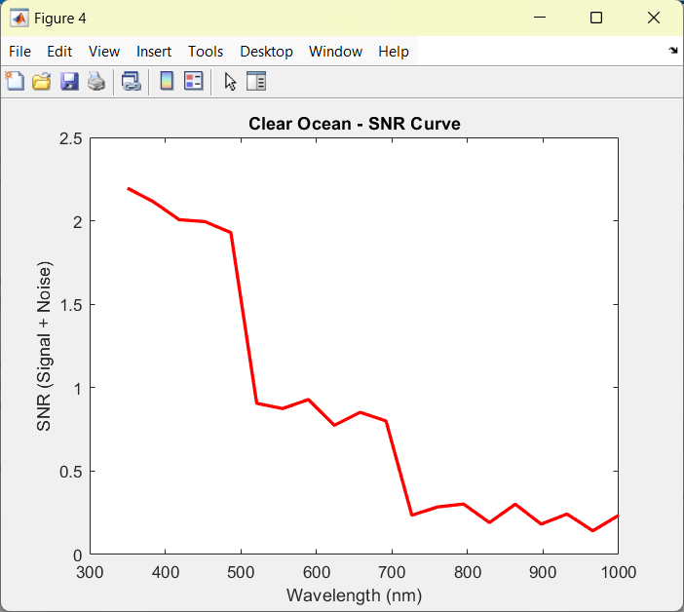

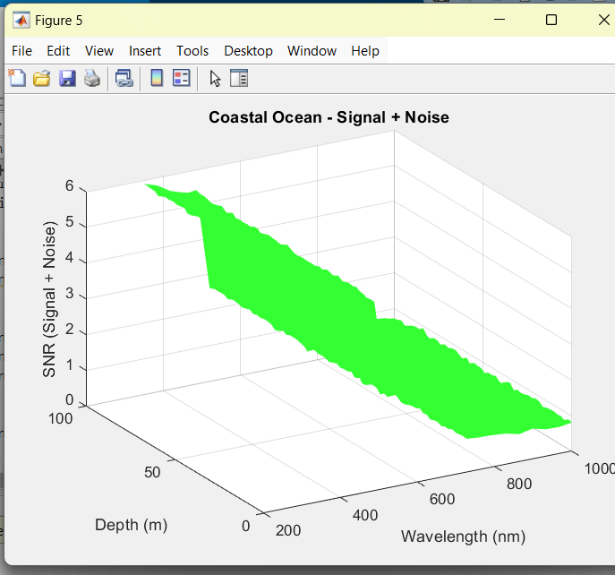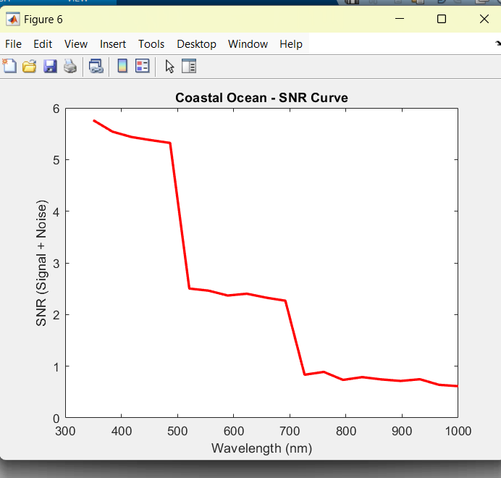

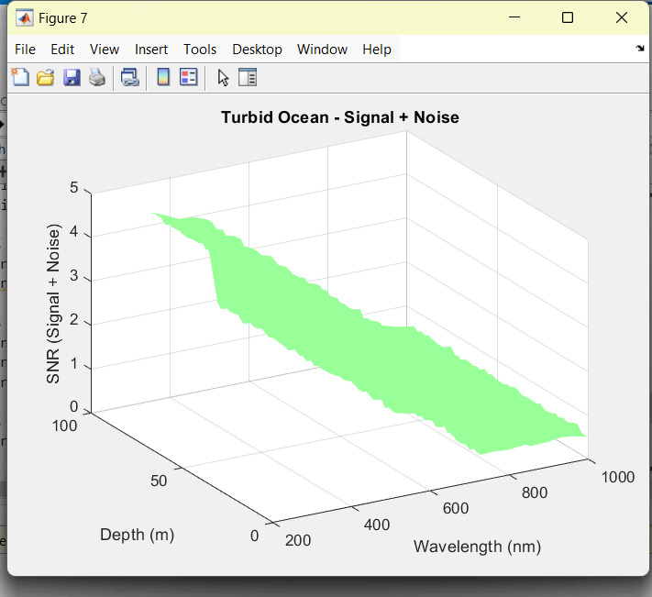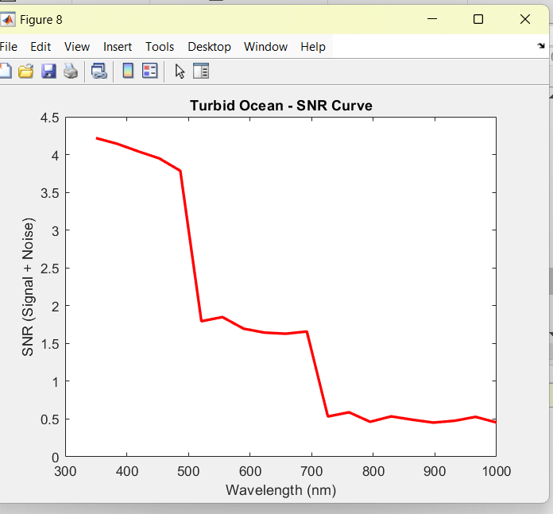

**Fig 25:** SNR Curves with different ocean beds with and without noise and their LOC structure

LOC is a concept in underwater acoustics, particularly for understanding and predicting how sound waves propagate in the ocean.

**Sound Ray Propagation:**

1.Sound waves in water don't travel in straight lines like light waves in air. Instead, they follow a curved path due to changes in water properties such as temperature, salinity, and pressure.

2. The line of curvature (LOC) represents the path along which sound rays curve as they travel through water.

3. Understanding the LOC is crucial for predicting the trajectory of sound waves and determining how they will propagate in the ocean.

**Sound Refraction:**

Refraction is the bending of sound waves as they pass through regions with different water properties. This bending occurs due to changes in the speed of sound caused by variations in temperature, salinity, and pressure.

**Underwater Communication:**

1.The LOC helps in designing communication systems by providing insights into how sound signals will travel through the water column.

2. Engineers can use knowledge of the LOC to optimize the placement of transmitters and receivers for efficient communication.

**Sonar Systems:**

LOC is crucial for interpreting sonar signals. It helps in determining the range, bearing, and depth of detected objects by accounting for the refraction of sound waves.

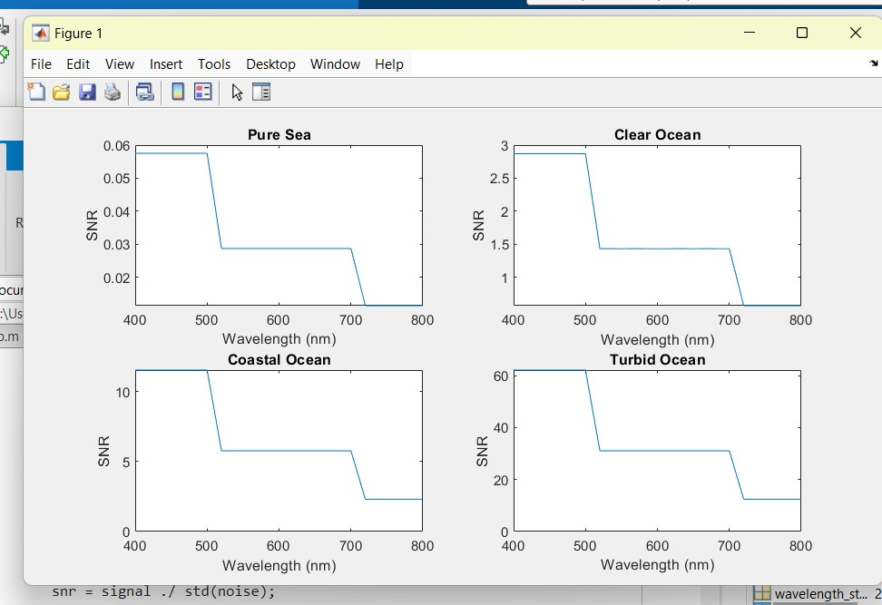

**Fig 26**: Clean graph

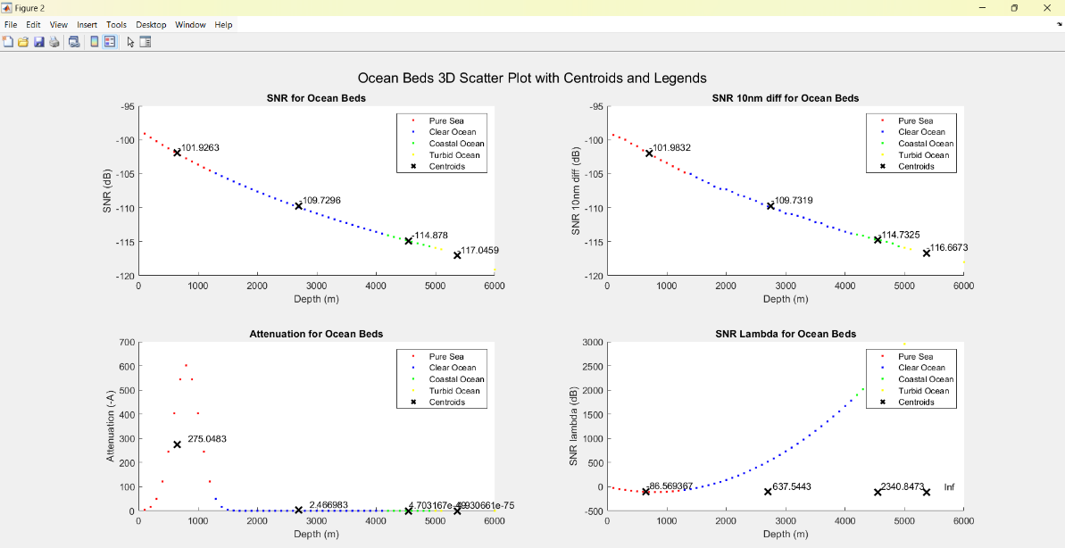

**Fig 27:** Ocean beds categorization

**CONCLUSION**

From these results we can conclude and get an understanding about how our parameters like SNR, BER, Attenuation, Nature of the ray many other is effected by the length of the fiber, the wavelength, Temp and many other factors either directly or due to addition of parameters and value like the values of h,c,lambda etc.

**ACKNOWLEDGMENT**

We would like to express my gratitude to Prof Ananda M, Associate Professor, Department of Electronics and Communication Engineering, PES University, for his continuous guidance, assistance, and encouragement throughout the development of this Project. We thank PES University for providing us the required support at the right time. Finally, this Project could not have been completed without the continual support and encouragement received from my family and friends.

**REFERENCES**

1. Underwater wireless-to-plastic optical fiber communication systems with a passive front end by Amjad Ali; Chao Zhang; S. A. Hassnain; Weichao Lyu; Riffat Tehseen; Xiao Chen

2. Underwater Optical Communications: A Brief Overview and Recent Developments by

Saleha Al-Zhrani,Nada M. Bedaiwi, Abeer Barasheed, Intesar El Ramley.

3. Real-Time Underwater Wireless Optical Communication System Based on LEDs and Estimation of Maximum Communication Distance by Minglun Zhang and Hongyu Zhou

4. Bridging optical fiber communication and underwater wireless optical communication via third harmonic generation by Haiwu Zou, Chao Zhang, Zihao Du, Xiyin Wang, Haipeng Wang, Guangbin Song, Yufan Zhang, Hao Zhang, Yunhai Gao, Bo Wu, Shiming Gao, and Jin Xu.

5.Underwater Communication: A Detailed Review by Suresh Kumar

6.Underwater Optical Wireless Communication by Hemani Kaushal; Georges Kaddoum

7. Underwater Optical Wireless Communications by Giuseppe Schirripa Spagnolo, Lorenzo Cozzella, and Fabio Leccese.

8.High-Speed Underwater Optical Wireless Communication with Advanced Signal Processing Methods Survey by by Chengwei Fang 1,Shuo Li , Yinong Wang and Ke Wang .

9.Underwater optical wireless communications, networking, and localization: A survey by Nasir Saeed, Abdulkadir Celik, Tareq Y. Al-Naffouri, Mohamed-Slim Alouini.

10.Underwater optical wireless communication system performance improvement using convolutional neural networks by Omar Nameer Mohammed Salim, Salah A. Adnan ,Ammar Hussein Mutlag

11.S. A. Adnan, A. Alchalaby, and H. A. Hassan, “Future optimization algorithm to estimate attenuation in 532 nm laser beam of UWOC-channel: Improved neural network model,” Math. Modell. Eng. Problems 8, 453 (2021).

12. S. A. Adnan, H. A. Hassan, A. Alchalaby, and A. C. Kadhim, “Experimental study of underwater wireless optical communication from clean water to turbid harbor under various conditions,” Int. J. Des. Nature Ecodyn. 16, 219 (2021).

13.G. Cossu, R. Corsini, A. M. Khalid, S. Balestrino, A. Coppelli, A. Caiti, and E. Ciaramella, “Experimental demonstration of high speed underwater visible light communications,” in 2013 2nd International Workshop on Optical Wireless Communications (IEEE, 2013), Vol. 11.

14.S. Adnan, M. Ali, and F. Hakwar, “The air bubbles effect for underwater optical wireless communication using 650 nm wavelength,” Eng. Technol. J. 37, 398 (2019).

15.J. Wang, C. Lu, S. Li, and Z. Xu, “100 m/500 Mbps underwater optical wireless communication using an NRZ-OOK modulated 520 nm laser diode,” Opt. Express 27, 12171 (2019).

16.P. Tian, X. Liu, S. Yi, Y. Huang, S. Zhang, X. Zhou, L. Hu, L. Zheng, and R. Liu, “High-speed underwater optical wireless communication using a blue GaN-based micro-LED,” Opt. Express 25, 1193 (2017).

17.X. Yu, W. Jin, M. Sui, and Z. Lan, “Evaluation of forward error correction scheme for underwater wireless optical communication,” in 2011 Third International Conference on Communications and Mobile Computing (IEEE, 2011), Vol. 527.

18.A. Liu, R. Zhang, B. Lin, and H. Yin, “Multi-degree-of-freedom for underwater optical wireless communication with improved transmission performance,” J. Mar. Sci. Eng. 11, 48 (2022).

19.I. C. Ijeh, M. A. Khalighi, and S. Hranilovic, “Parameter optimization for an underwater optical wireless vertical link subject to link Misalignments,” IEEE J. Oceanic Eng. 46, 1424 (2021).

20.Towards underwater coherent optical wireless communications using a simplified detection scheme by XINKE TANG,

RUPESH KUMAR, CAIMING SUN, LONG ZHANG, ZHEN CHEN, RUI JIANG, HONGJIE WANG, AND AIDONG ZHANG.

21. I. Roudas, “Coherent Optical Communication Systems,” in WDM Systems and Networks, Modeling, Simulation,

Design and Engineering, N. Antoniades, G. Ellinas, and I. Roudas, eds. (Springer, 2012).

22.K. Kikuchi, “Fundamentals of Coherent Optical Fiber Communications,” J. Lightwave Technol. 34(1), 157–179

(2016).

23.E. Ip, A. P. T. Lau, D. J. F. Barros, and J. M. Kahn, “Coherent detection in optical fiber systems,” Opt. Express 16(2),

753–791 (2008).

24. X. Tang, L. Zhang, C. Sun, Z. Chen, H. Wang, R. Jiang, Z. Li, W. Shi, and A. Zhang, “Underwater Wireless Optical

Communication Based on DPSK Modulation and Silicon Photomultiplier,” IEEE Access 8, 204676–204683 (2020)

25. B. Zhang, C. Malouin, and T. J. Schmidt, “Design of coherent receiver optical front end for unamplified applications,”

Opt. Express 20(3), 3225–3234 (2012).

26. M. J. Connelly, “COHERENT LIGHTWAVE SYSTEMS,” in Encyclopedia of Modern Optics, R. D. Guenther, Ed.

(Elsevier, 2005).

27.X. Sun, M. Kong, O. Alkhazragi, C. Shen, E.-N. Ooi, X. Zhang, U. Buttner, T. K. Ng, and B. S. Ooi, “Non-line-of-sight

methodology for high-speed wireless optical communication in highly turbid water,” Opt. Commun. 461, 125264

(2020).

28.A. Laux, R. Billmers, L. Mullen, B. Concannon, J. Davis, J. Prentice, and V. Contarino, “The a, b, c s of oceanographic

lidar predictions: a significant step toward closing the loop between theory and experiment,” J. Mod. Opt. 49(3-4),

439–451 (2002).

29. . J. Zhao, Y. Liu, and T. Xu, “Advanced DSP for Coherent Optical Fiber Communication,” Appl. Sci. 9(19), 4192

(2019).

30. X. Zhou and J. Yu, “Digital signal processing for coherent optical communication,” in 2009 18th Annual Wireless

and Optical Communications Conference, (IEEE, 2009), pp. 1–5.